



USER

GUIDE

ADMIN GUIDE

N EW D E L H I

S EP T EM B ER 2 0 2 2

Table of Contents

Introduction 4

1. Home 5

2. About 6

3. Information Kiosk 7

4. Contact 8

5. Login 9

5.1 At a Glance 10

5.1.1 Users 10

5.1.2 Cash Transfer 11

5.1.3 Mentoring 14

5.1.4 Referral 17

5.1.5 Grievance/Complaint 18

5.2 Pre-Registration 20

5.2.1 Export Pre-Registration 20

5.2.2 Import Pre-Registration 23

5.2.3 Add Pre-Registration 24

5.3 Registration 26

5.3.1 Export Registration 27

5.3.2 Import Registration 29

5.3.3 Add Registration 30

5.3.4 Approve/Reject Registration 33

5.3.5 Assign Mentor 37

5.4 Cash Transfer 39

5.4.1 Eligible 40

5.4.2 First Verification 41

5.4.3 Second Verification 43

5.4.4 Approval 45

5.4.5 Payment 47

5.5 Admin 50

5.5.1 Summary 51

5.5.2 Manage Area 53

5.5.3 Manage Cohort 58

5.5.4 Manage School 60

5.5.5 Manage Master List 62

5.5.6 Manage User 64

5.5.7 Manage Resources 67

5.5.8 Manage Log 69

# Introduction

The **Girls Empowering Girls** (GEG) **Management Information System** (MIS) is developed as a web-based MIS system that includes data collection, transaction management and reports generation modules to automate beneficiary management in the GEG program. The platform has tools developed for various processes including pre-registration, registration, cash transfers, mentoring, referral and grievance/complaint management. The platform will comprise of various independent modules. Below is the list of all the modules -

1. Home
2. About
3. Information Kiosk
4. Contact
5. Login

5.1 At a Glance

5.2 Pre-Registration

5.3 Participant Registration

5.4 Cash Transfer

5.5 Admin

5.6.1 Summary

5.6.2 Manage Area

5.6.3 Manage Cohort

5.6.4 Manage School

5.6.5 Manage Master List

5.6.6 Manage User

5.6.7 Manage Resource

5.6.8 Manage Log

5.6.9 Audit Trail

5.7 Reports

Below chapters explains the above modules in details.

# Home

The **GEG MIS** platform is a web-based system which can be accessed through a web browser (recommended browser - Google Chrome latest version). Enter URL <https://itmcloud.org/geg/dashboard/> in the web browser. The first page you will get to view is the home page. The home page is the landing page of the GEG MIS Portal and has the following options available to navigate through all the modules of the portal - **About**, **Information Kiosk, Contact** and **Login**.

This module presents the dynamic key facts along with a background image which keeps changing in fixed interval of time (see below figure).

# About

Click on the **About** menuoption from the home page to navigate to the module. This module presents the detailed information about **Girls Empowering Girls** programme and its objectives.

# Information Kiosk

Click on the **Information Kiosk** menuoption from the home page to navigate to the module. This module presents the reference documents relevant to the GEG MIS portal. You will be able to view the **Resources** grouped by category. You can either view **All** the resources or filter them by category. You can also **Search** resources by entering text in search bar available at the top right corner. Additionally, you can **Sort** the resources in alphabetical order and in the order of its date of creation by clicking on the respective sorting buttons (see below figure).

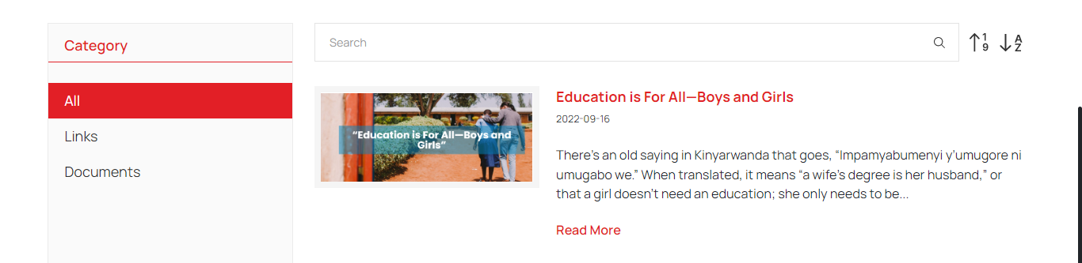Click on **Read More** button available with each resource to read full description of the resource (see below figure).

# Contact

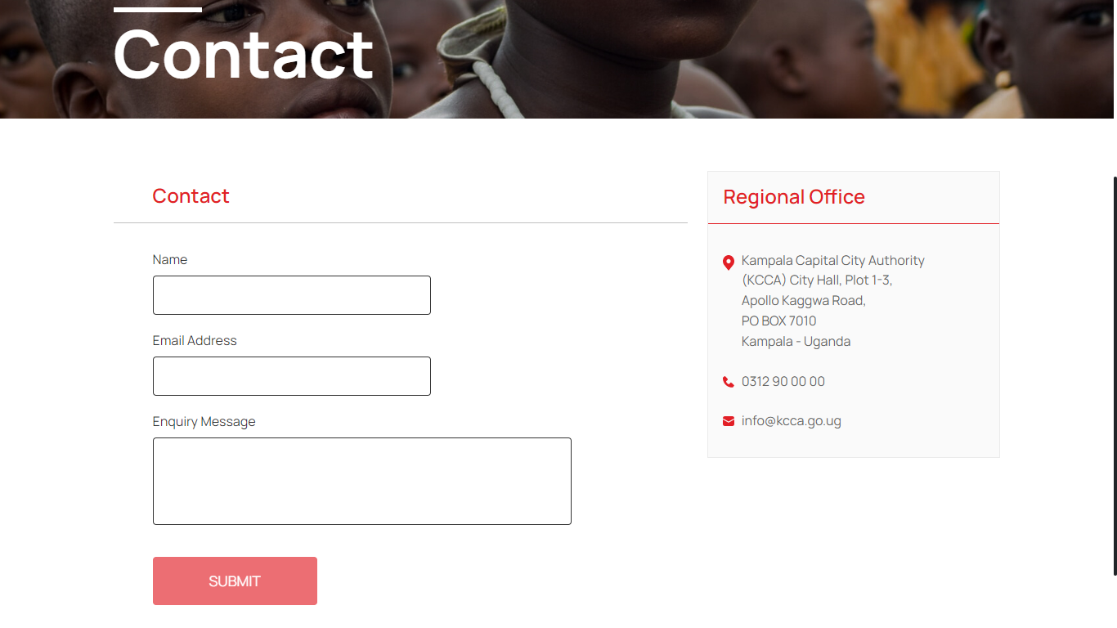Click on the **Contact** menuoption from the home page to navigate to the module. This module provides the Address and Contact details of KCCA Regional Office. To send enquiry message to KCCA officials, enter **Name**, **Email** **Address**, **Enquiry Message** and click on Submit (see below figure).

# Login

Click on the **Login** option from the home page and enter valid **Email ID** & **Password** to login into the GEG MIS Portal (see below figure).

## At a Glance

This is the first module after the successful login into the portal. This module can be accessed by all the users and is cohort and time period driven. This module presents summarized data on Cash Transfer, Mentoring, Referral and Grievance / Complaints of the participants using various visualizations. Each data is presented in widget with option to view the detailed information of the selected data.

### 5.1.1 Users

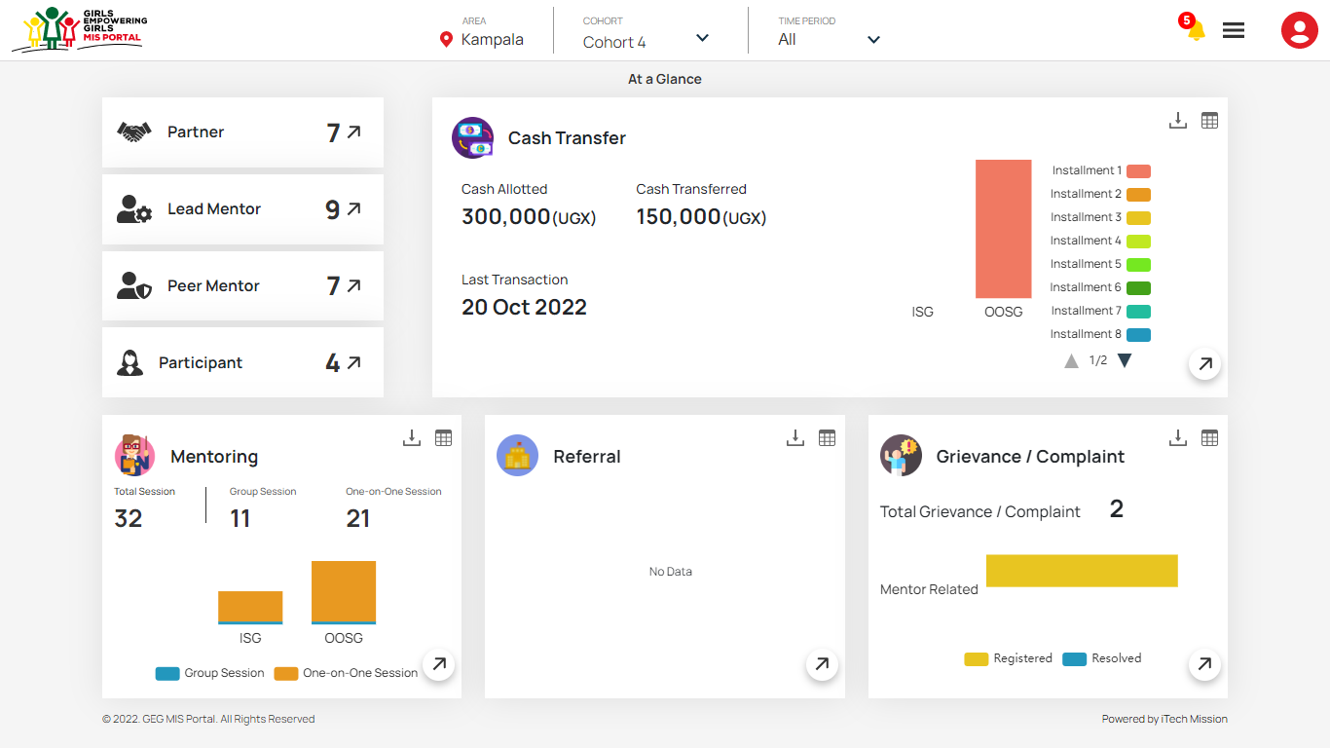Count of users by role is shown to the left side of the page (see below figure). Click on the **Arrow** button available with each role to view the list of users in the selected role.

### 5.1.2 Cash Transfer

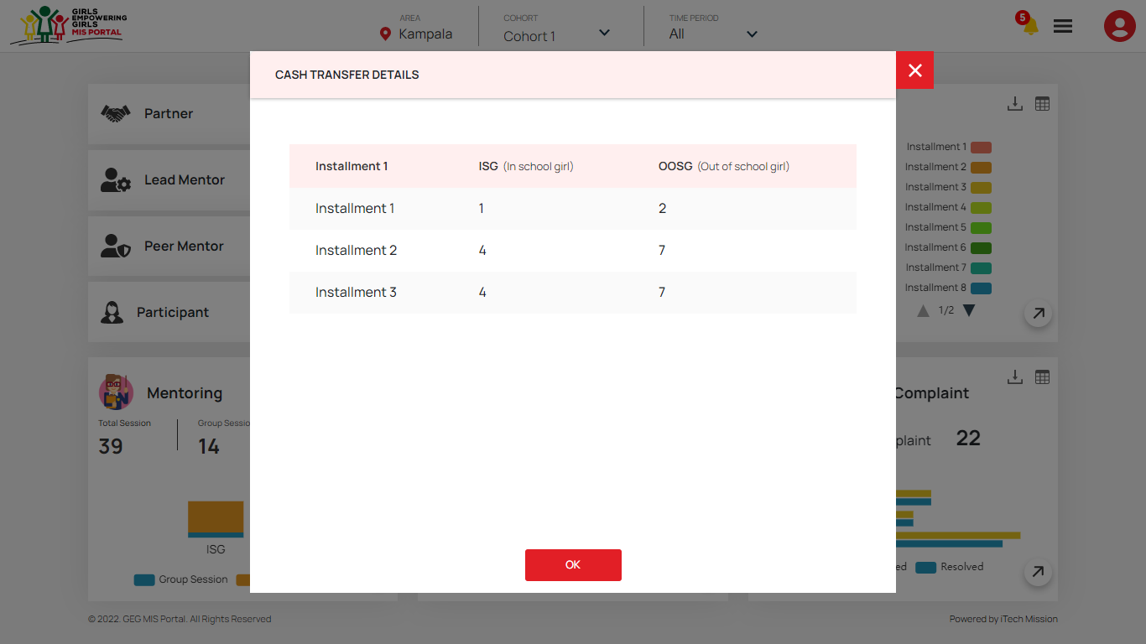Next is the Cash transfer widget which presents the summarized data on cash transferred to the participants. The widget provides the information about the total Cash Allotted, Cash Transferred and Last Transaction date of the selected cohort. Installment data of In-School and Out-of-Schools girls are also presented with the help of stack column chart. The legend for the data is available to the right side of the visualization. Click on the **Table** button available at the top right corner to view the Cash Transfer data in tabular grid (see below figure).

Click on the **Download** button to download the cash transfer data in JPEG format. Click on the **Arrow** button available at the bottom to view the detailed information on cash transfer for each participant (see below figure).

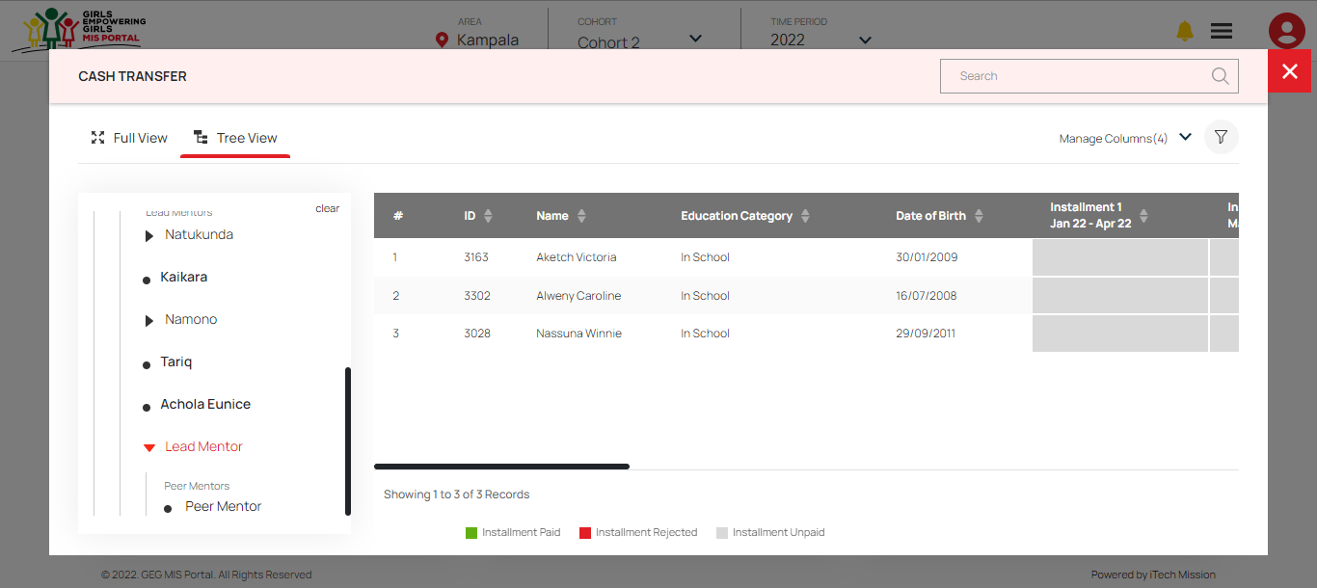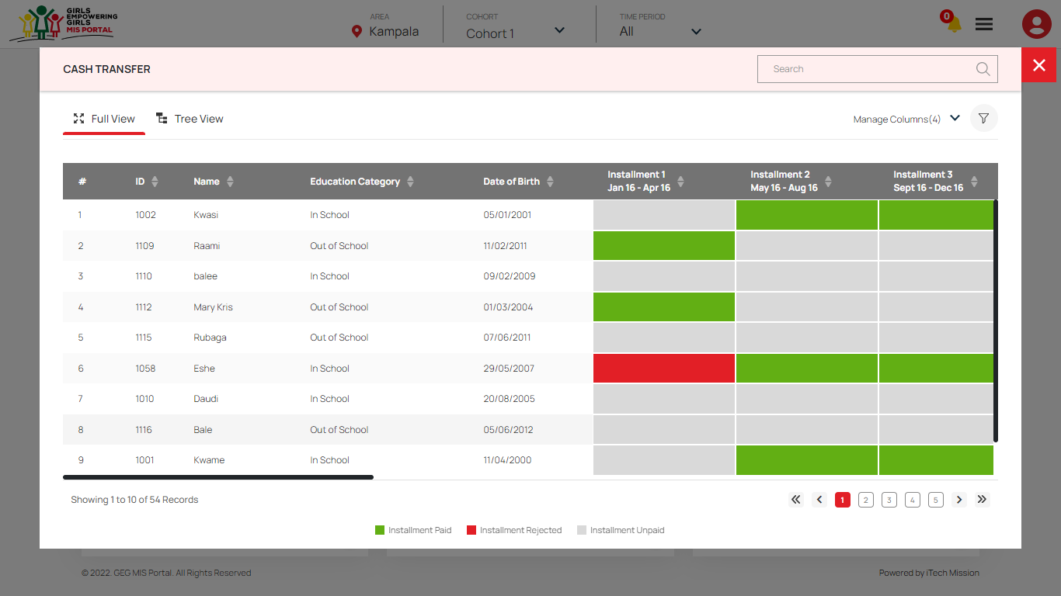The detailed cash transfer data is presented in two views – **Full View** and **Tree View**. By default, full view will be selected and the cash transfer detail of all the participants is presented using heat map visualization. The legends for the paid and rejected installment is available at the bottom. Click on the **Tree View** option to view the cash transfer data of all the participants by their assigned peer mentors (see below figure).

You can click on the name of **Partners** available to the left side to view the lead mentors assigned to the selected partner, peer mentor assigned to the selected lead mentor and participants cash transfer details assigned to the selected peer mentor.

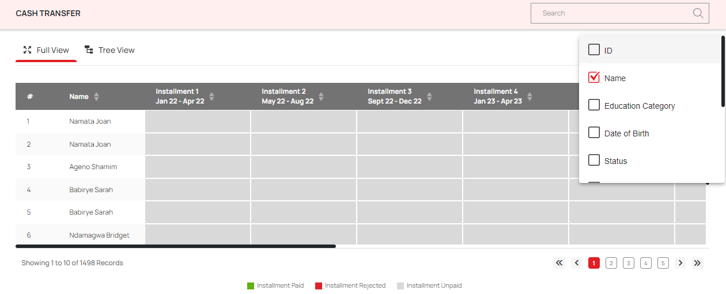Click on the **Manage Columns** option available to show/hide the columns of the table (see below figure)

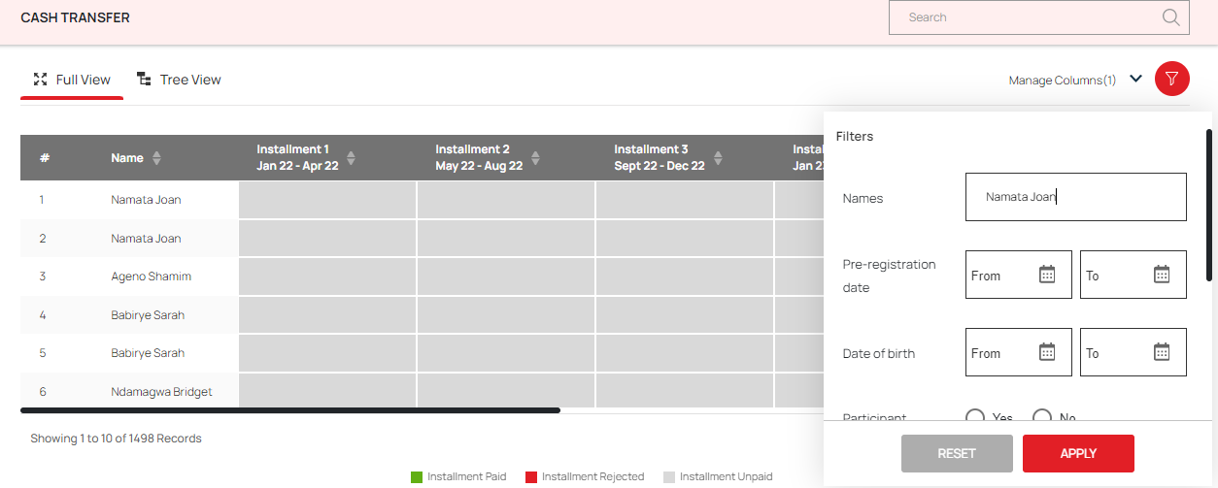Click on the **Filter** option to filter the cash transfer data based on the selected parameter (see below figure).

### 5.1.3 Mentoring

**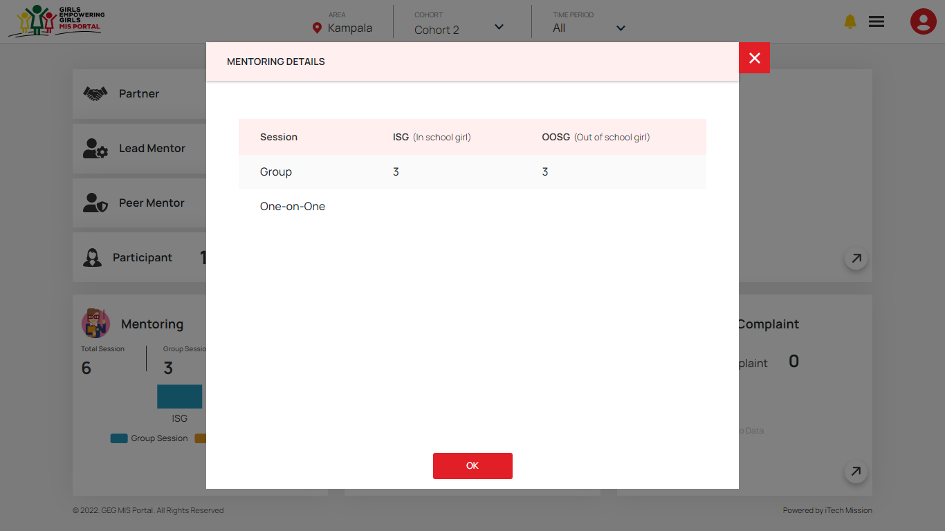****Mentoring** widget presents the summarized data of the sessions conducted with the participants using the stack column chart. The legend for the data is available to the right side of the visualization. Click on the **Table** button available at the top right corner to view the Mentoring data for both ISG and OOSG in tabular grid (see below figure).

Click on the **Download** button to download the mentoring data in JPEG format. Click on the **Arrow** button available at the bottom to view the detailed information on mentoring sessions conducted with each participant (see below figure).

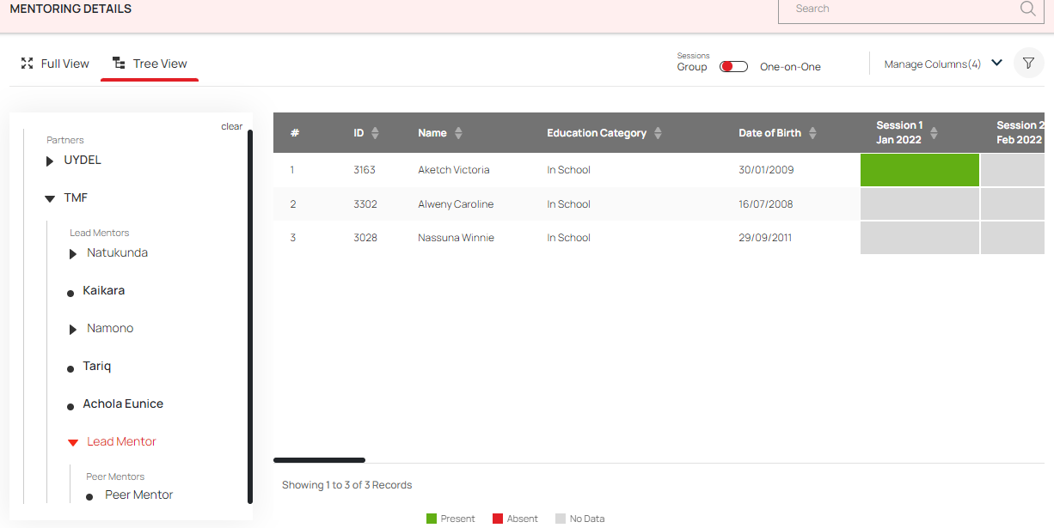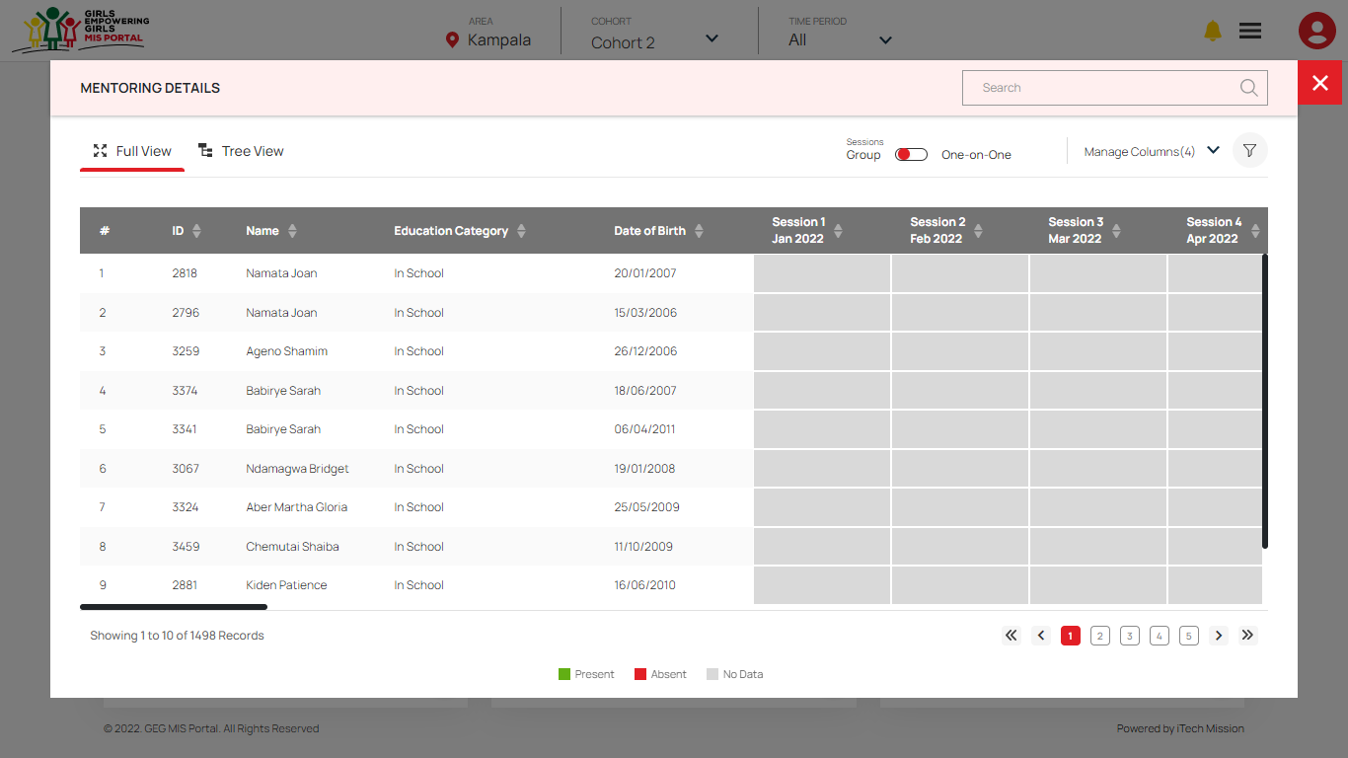The detailed mentoring data is presented in two views – **Full View** and **Tree View**. By default, full view will be selected and the mentoring data will be presented for all the participants using heat map visualization. The legends for the data are available at the bottom. Click on the **Tree View** option to view the mentoring data of all the participants by their assigned peer mentors (see below figure).

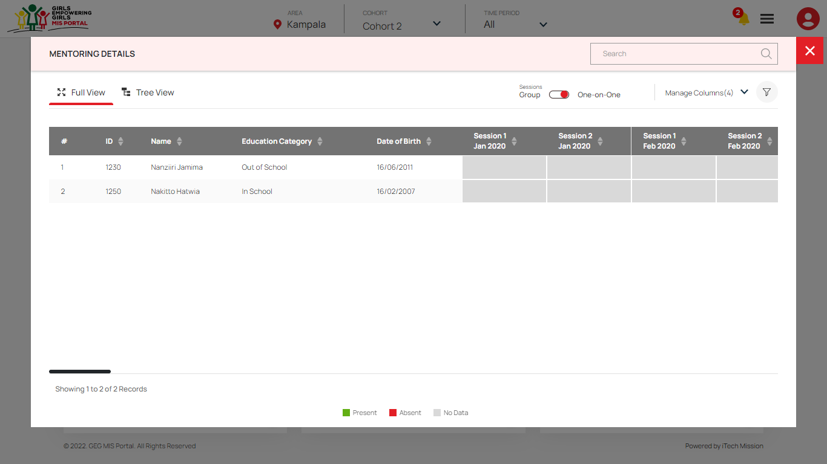Click on the **Session** toggle buttons to view the group session’s or one on one session’s data of each participant (see below figure).

Click on the **Manage Columns** option available to show/hide the columns of the table and click on the **Filter** option to filter the mentoring data based on the selected parameter.

### 5.1.4 Referral

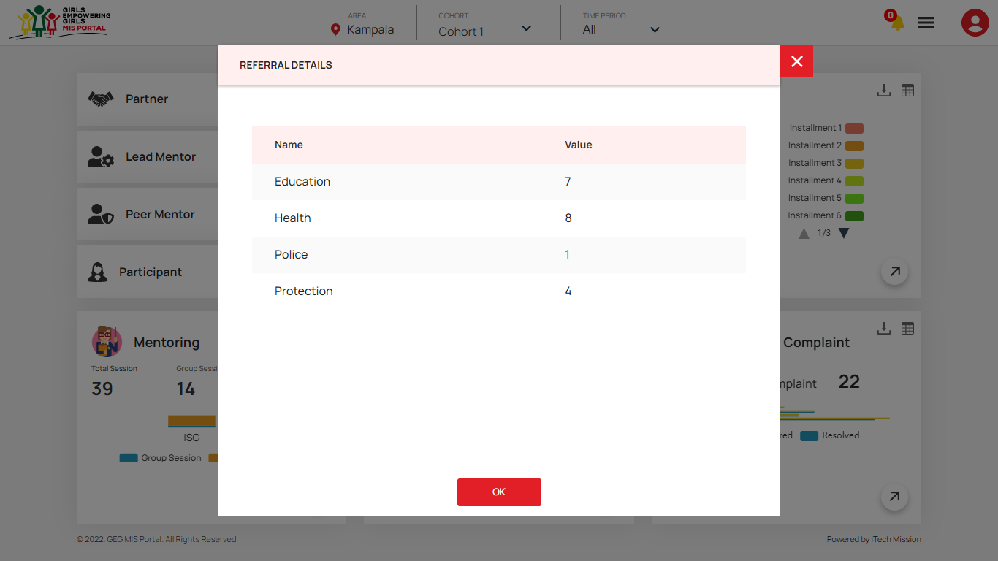**Referral** widget presents the summarized data on the referrals of the participants. The category wise referral’s data is presented using the donut chart where the color of each portion of the donut represents the category of the referral. Click on the **Table** button available at the top right corner to view the count of referral in each category (see below figure).

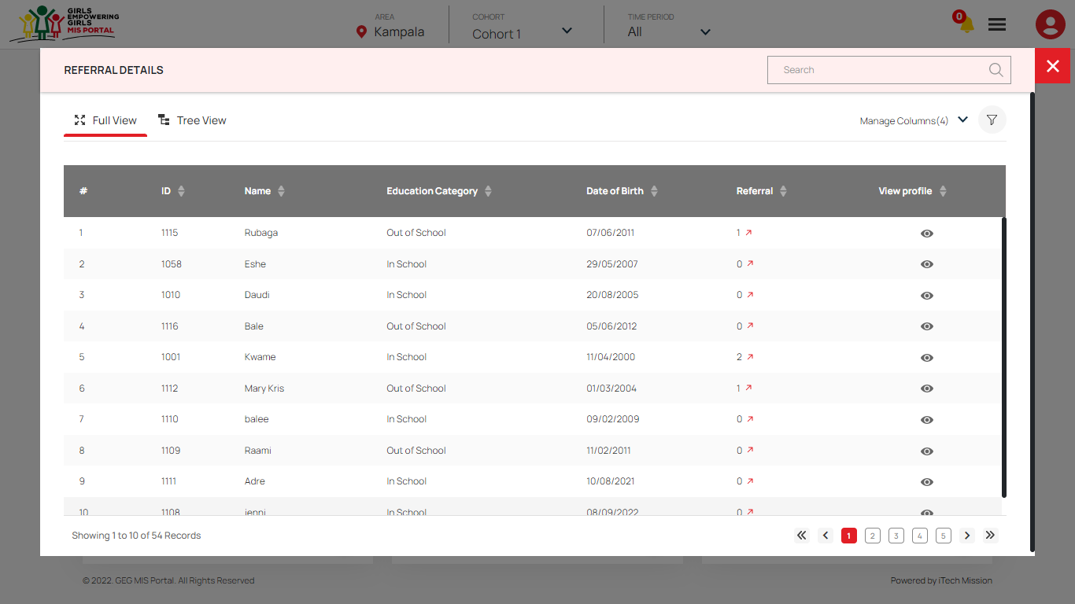Click on the **Download** button to download the referral data in JPEG format. Click on the **Arrow** button available at the bottom to view the detailed information on referrals of each participant (see below figure).

### 5.1.5 Grievance/Complaint

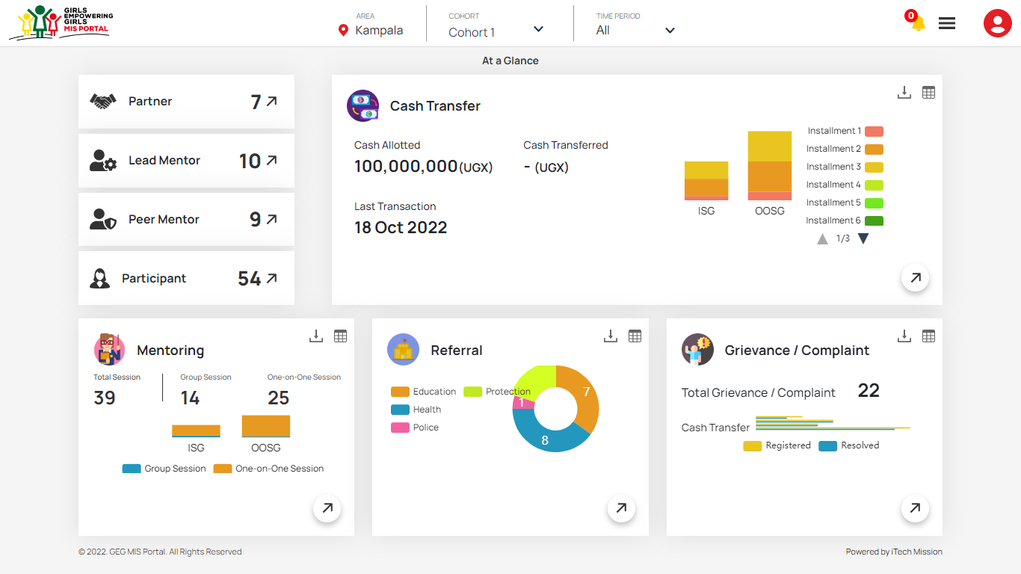**Grievance/Complaint** widget presents the summarized data on the grievance of the participants in various categories. The widget presents the total count of grievance registered and resolved using bar chart visualization (see below figure).

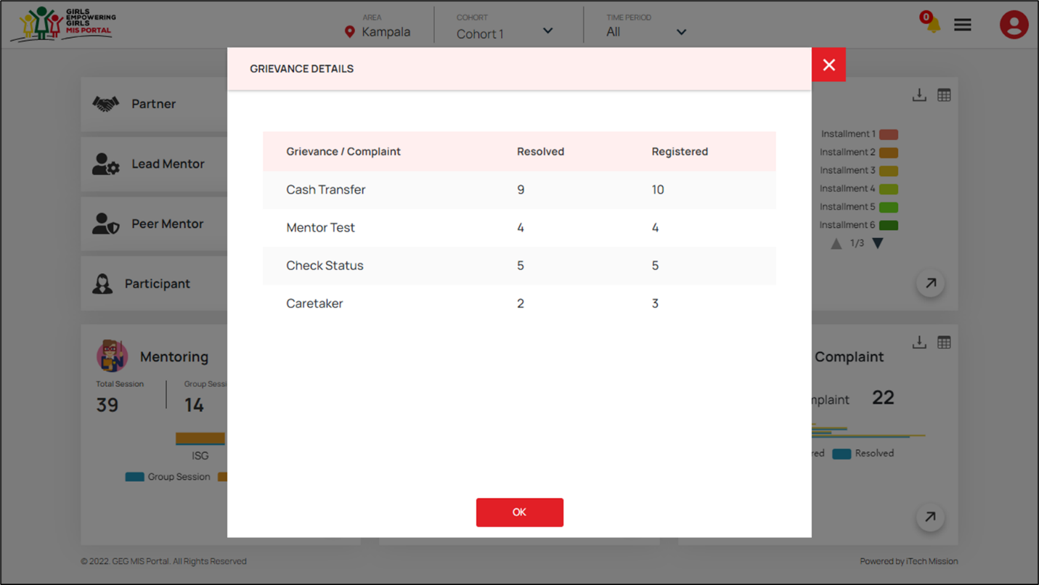Click on the **Table** button available at the top right corner to view the category wise count of resolved and registered Grievance of the participant in tabular grid (see below figure).

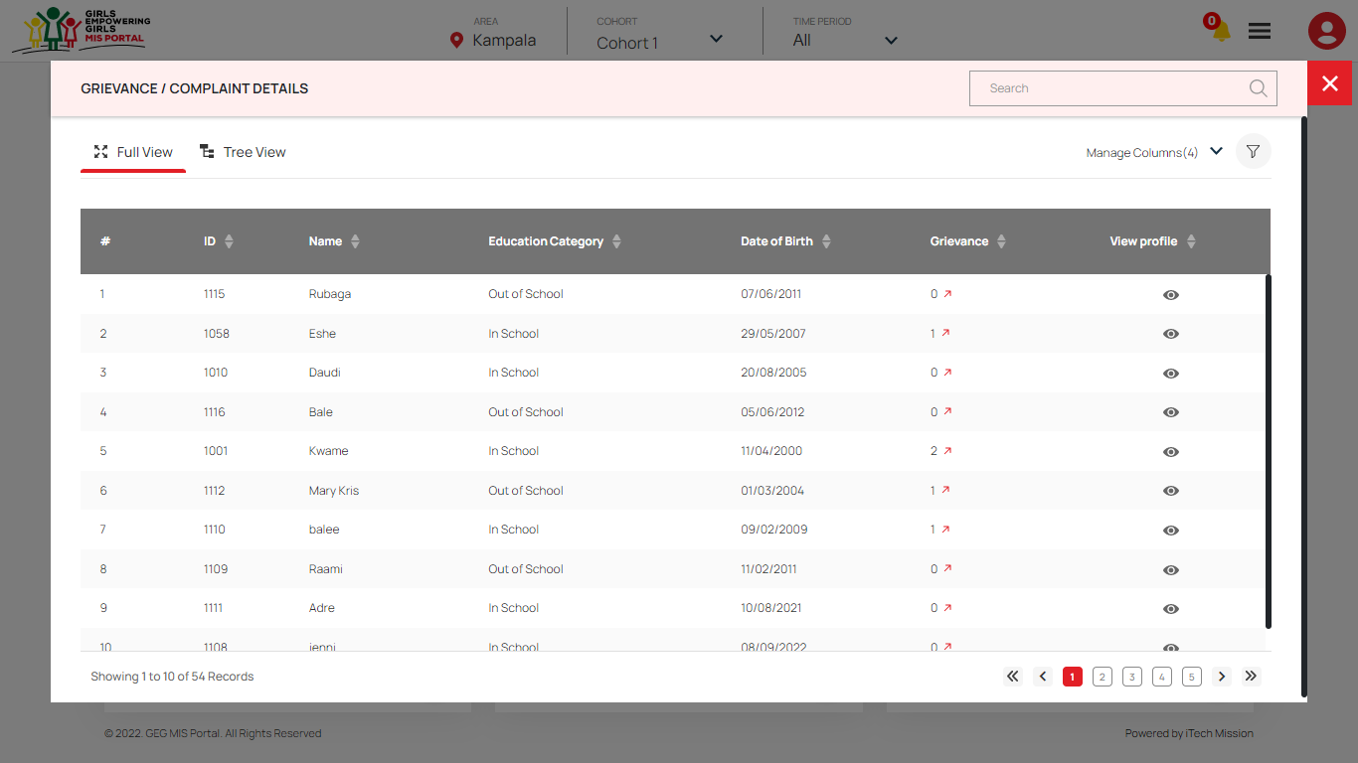Click on the **Download** button to download the grievance data in JPEG format. Click on the **Arrow** button available at the bottom to view the detailed information on grievance of each participant (see below figure).

The detailed grievance data is presented in two views – **Full View** and **Tree View**. By default, full view will be selected and you will be able to view the grievance data of all the participants by clicking on the **arrow** button available with the count of grievance under grievance column.

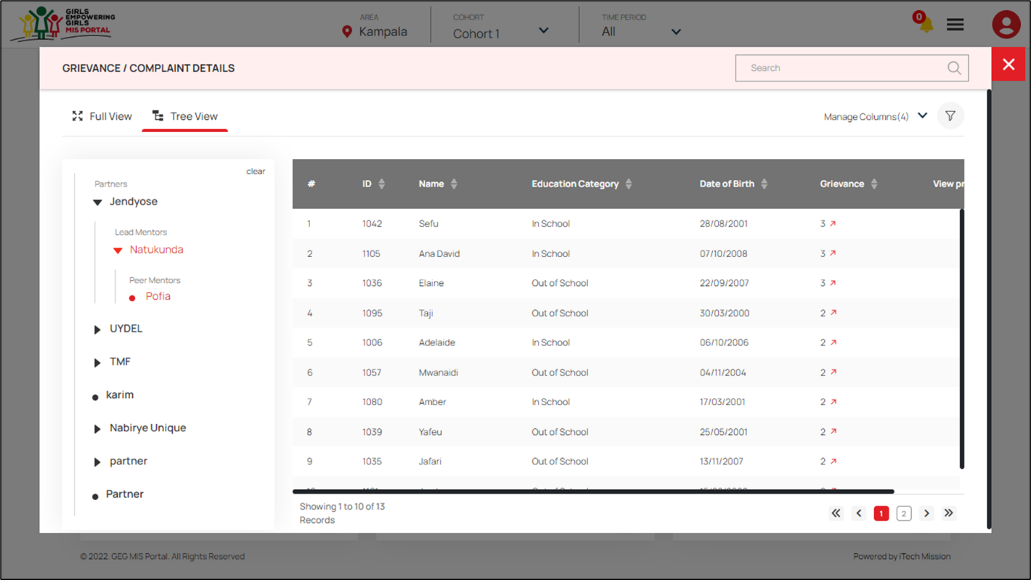Click on the **Tree View** option to view the grievance data of all the participants by their assigned peer mentors (see below figure).

## Pre-Registration

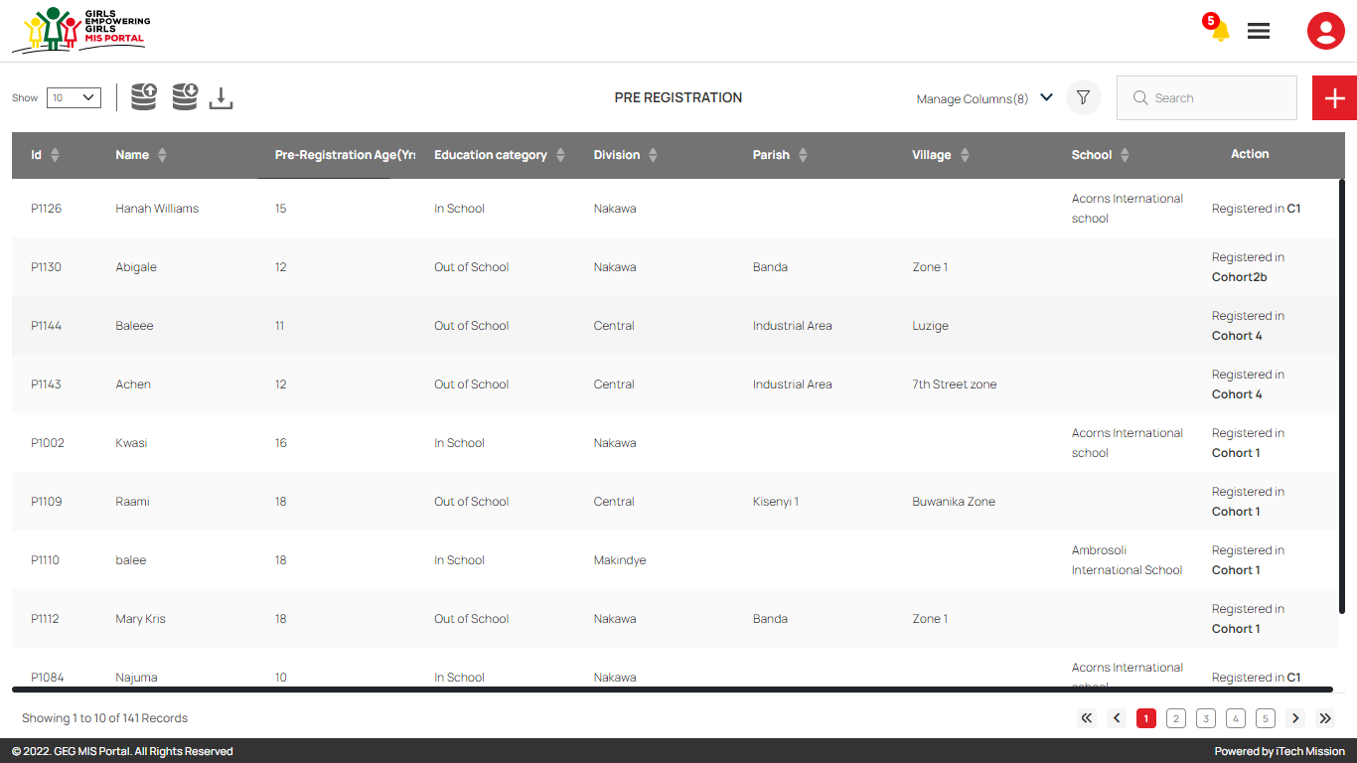After successful login, click on the **Pre-Registration** option from **Burger** menu to access this module. This module allows you to manage the potential candidates that can be selected as participants of the GEG programme. You have the options to export and import a pre – registration data, add new candidate, view the list of existing candidates, sort the list, search candidate from the list, delete and update existing candidates (see figure below).

### 5.2.1 Export Pre-Registration

By clicking on the **Export** button, a pop-up window appears (see below figure). You can download the pre-registration empty template and pre-registered data available in the database (see below figure).

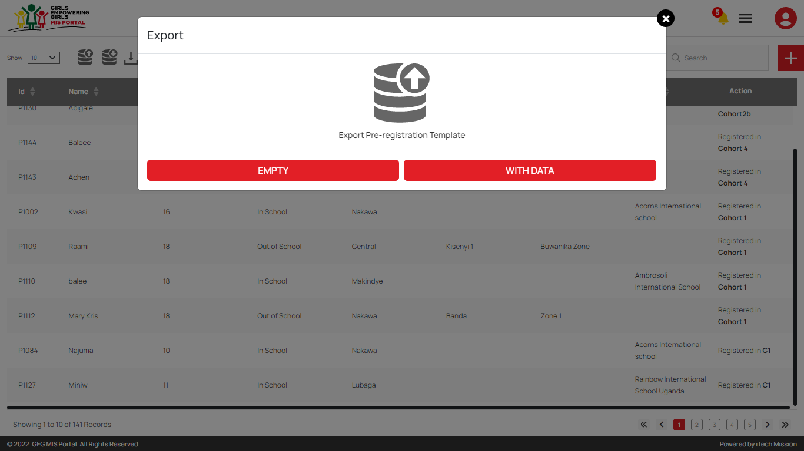Below is the structure of the pre-registration template.

|  |  |
| --- | --- |
| **Registration Date** | The pre-registration date of candidate |
| **Name** | Name of the pre-registered candidate |
| **Age** | Age of the pre-registration candidate |
| **Division** | Division in the candidate address |
| **Parish** | Parish in the candidate address |
| **School** | Name of the school (Incase candidate’s education category is In-school). |
| **Village** | Village in the candidate address |
| **Education Category** | Education category of the candidate (Either In school or Out of School). |
| **School Status** | The status of candidate whether they are attending school or not. |
| **Year Dropped** | The Year candidate dropped out of school (When school status is selected as NO). |
| **Vulnerability Pregnant** | To determine incase the vulnerability of the pre-registered candidate is that she is pregnant. |
| **Vulnerability Disability** | To determine incase the vulnerability of the pre-registered candidate is disability. |
| **Vulnerability Refugee** | To determine incase the vulnerability of the pre-registered candidate is that she is refugee. |
| **Vulnerability Orphan** | To determine incase the vulnerability of the pre-registered candidate is that she is orphan. |
| **Vulnerability Other** | To determine incase the vulnerability of the pre-registered candidate is other than given options. |
| **Vulnerability Other Text** | Describe your vulnerability if you have selected other from given options. |
| **Caretaker Name** | Name of the person who takes care of the pre-registered candidate. |
| **Caretaker Contact** | Contact number of the person who takes care of the pre-registered candidate. |

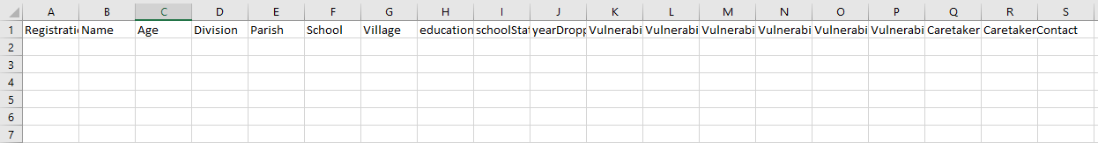By clicking on the **Empty** button, you can download an empty pre-registration template in CSV format and you can use this template to create the pre-registration data of the potential candidate (see below figure).

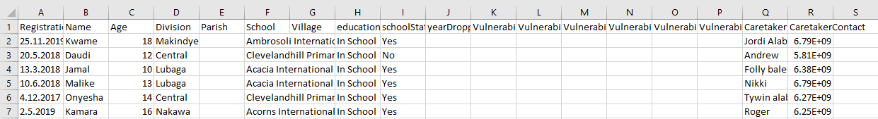Click on the **With Data** button to download the pre-registered candidate list available in the database (see below figure).

### 5.2.2 Import Pre-Registration

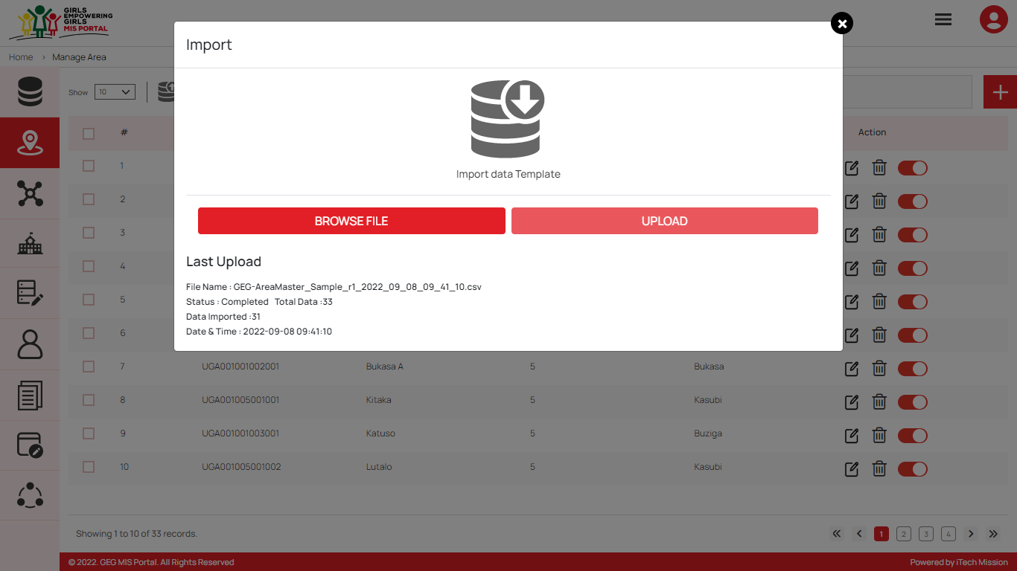By clicking on the **Import** button, a pop-up window appears (see below figure). You have the option to browse the file and upload the candidate list into the database.

To upload the candidate details into the database, first enter the candidate data in the exported template as explained above and then click on the **Browse File** button to select the template. Now, click on the **Upload** button to start the import process. During the import process, the records which contains blank entries, entries with special characters and duplicate entries will not be imported in the database.

The **Last Upload** summary provides the count of total and imported records. A log will be generated for the failed records along with the reason.

### 5.2.3 Add Pre-Registration

****Click on the **Plus** button to **Add** a new candidate into the pre-registration list (see figure below). Enter the following details to add a new candidate -

* Enter Candidate **Name**
* Select **Pre-Registration Date**
* Enter **Pre-Registration Age**
* Select **Education Category** (either In-school or Out of School)
* Select **Division**
* Select **Parish** (Incase education category is selected as Out of School)
* Select **Village** (Incase education category is selected as Out of School)
* Select **School** (Incase education category is as selected In School)
* Enter **Caretaker Name**
* Enter **Caretaker Address**

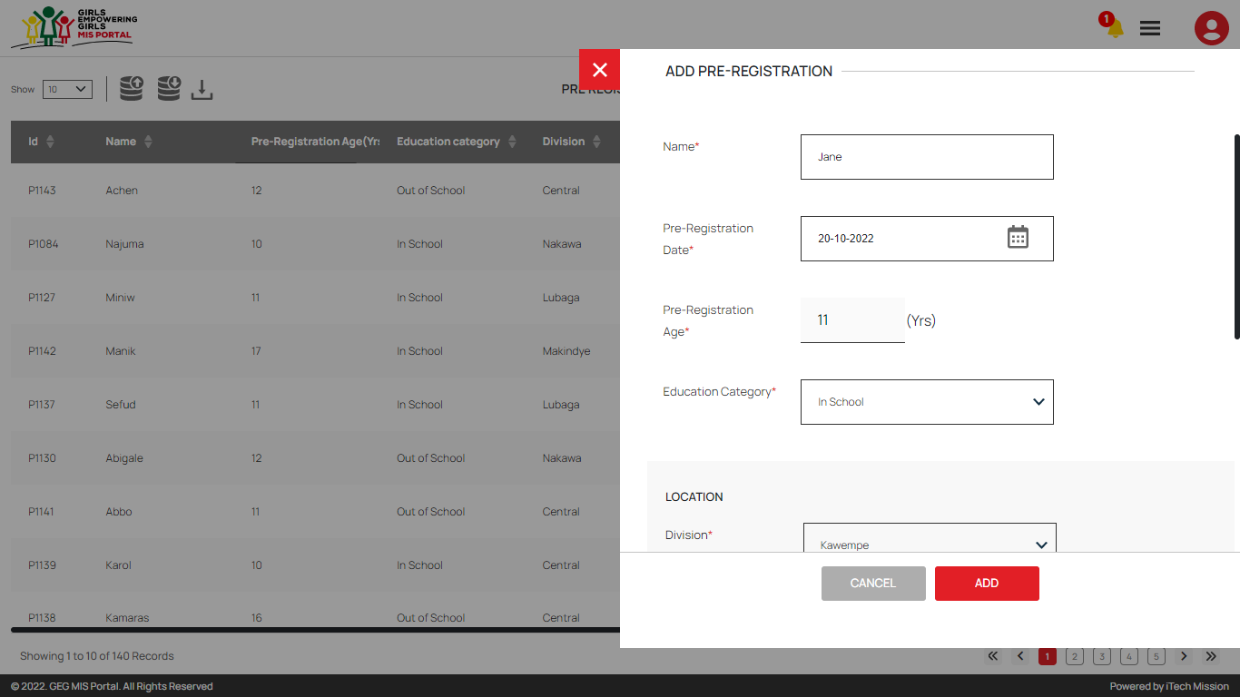All the details are mandatory to be entered. Click on the **Add** button to save and confirm. You can now view the candidate added in the pre-registration list.

Click on the **Edit** option from the Action column to edit any detail of the pre-registered candidate. Click on the **Update** button to save and confirm.

Click on the **Delete** option from the Action column to delete the selected candidate from the pre-registered list. When deleting a candidate, a confirmation popup will appear asking to confirm deletion. If clicked Yes, the selected record will be deleted.

Click on the **Disable** option from the Action column to disable the candidate. The disabled candidate will not be allowed for further registration process.

Click on the **Download** button available to the right side of the import button to download the pre-registered data along with the ID of each candidate.

## 5.3 Registration

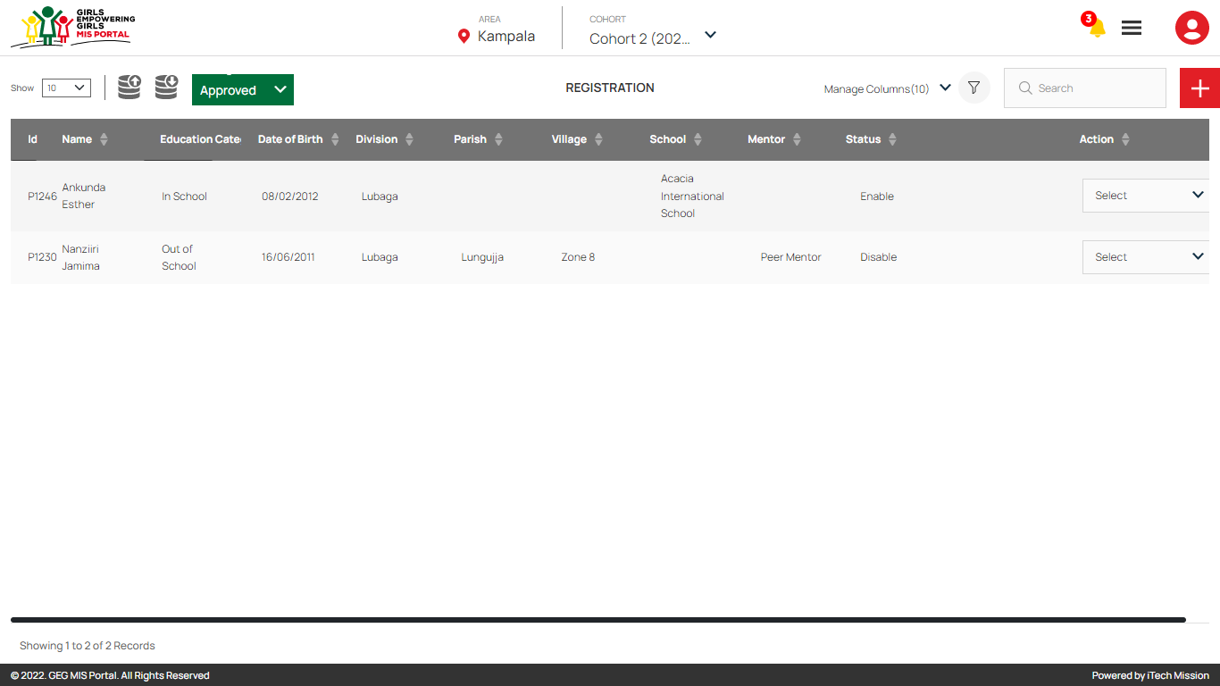Click on the **Registration** option from burger menu to access this module. This module is cohort and registration status driven and allows you to manage registration of participants in the GEG programme. You will have the options to export and import a participant registration data, add new participant, view the list of existing participants, approve or reject a pending participant, sort, search, delete and update the participants details (see figure below).

### 5.3.1 Export Registration

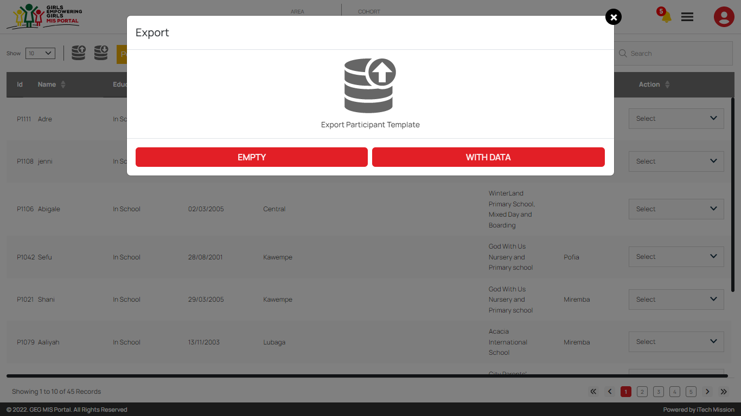****Click on the **Export** button to download the empty participant Registration template and participant data available in the database (See below figure).

Below is the structure of the registration template.

|  |  |
| --- | --- |
| **SNo** | The ID assigned to the pre-registered candidate |
| **Registration Date** | Date of registration of the participant |
| **Name** | Name of the of the participant |
| **DOB** | The date of birth of the participant |
| **Division** | Division of the participant |
| **Parish** | Parish of the participant |
| **School** | Name of the school of the participant. |
| **Village** | Village of the participant |
| **Education Category** | Education category of the participant |
| **School Status** | The status of participant whether they are attending school or not. |
| **Year Dropped** | The Year participant dropped out of school (When school status is selected as NO). |
| **Vulnerability Pregnant** | To determine incase the vulnerability of the pre-registered participant is that she is pregnant. |
| **Vulnerability Disability** | To determine incase the vulnerability of the pre-registered participant is disability. |
| **Vulnerability Refugee** | To determine incase the vulnerability of the pre-registered participant is that she is refugee. |
| **Vulnerability Orphan** | To determine incase the vulnerability of the pre-registered participant is that she is orphan. |
| **Vulnerability Other** | To determine incase the vulnerability of the pre-registered participant is other than given options. |
| **Vulnerability Other Text** | Describe your vulnerability if you have selected other from given options. |
| **Caretaker Name** | Name of the person who takes care of the pre-registered participant. |
| **Caretaker Contact** | Contact number of the person who takes care of the pre-registered participant. |

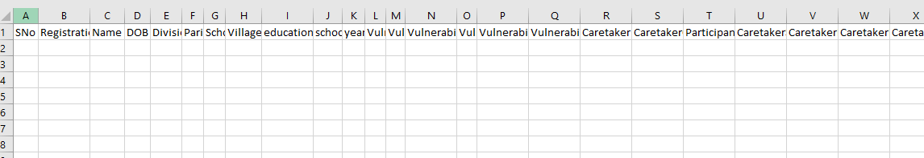Click on the **Empty** button to download an empty registration template in CSV format and you can use this template to create the registration data of the potential candidate (see below figure).

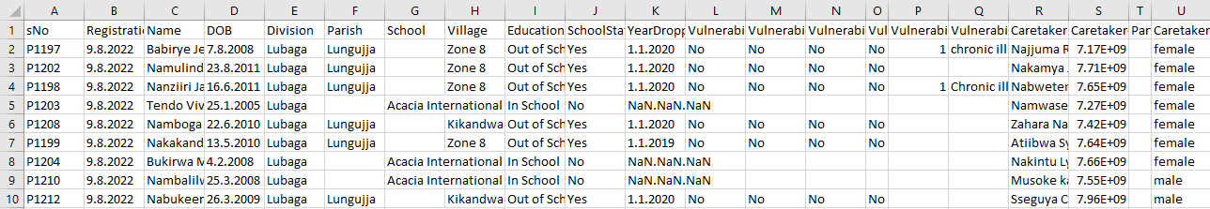Click on the **With Data** button to download the registration data available in the database (see below figure).

### 5.3.2 Import Registration

Click on the **Import** button to browse the file and upload the participant list into the database.

To upload the participant list into the database, first enter the participant details in the template as explained above and then click on the **Browse File** button to select the template. Now, click on the **Upload** button to start the import process. The records which contain blank entries, entries with special characters and duplicate entries will not be imported in the database.

The **Last Upload** summary provides the count of total and imported records. A log will be generated for the failed records which were duplicate, failed, successfully inserted and updated into the database out of the total records.

### 5.3.3 Add Registration

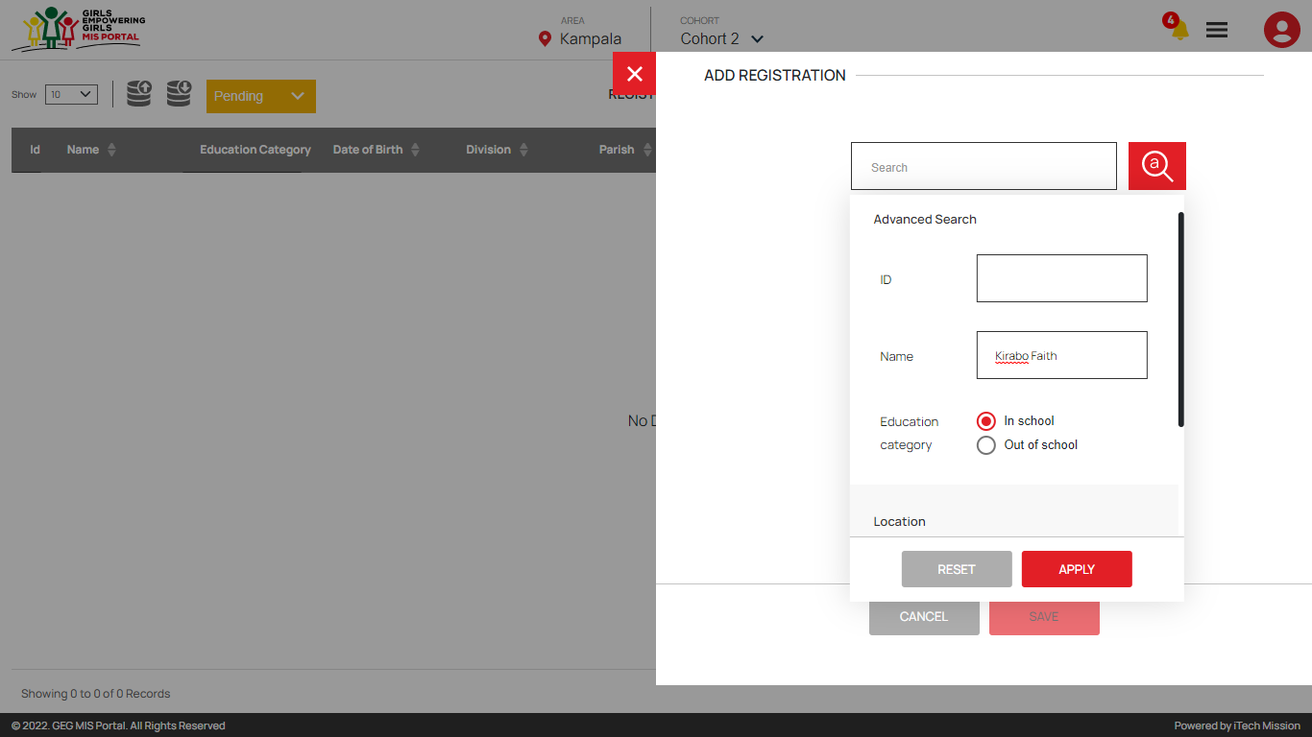****Click on the **Plus** button available to the right side of the page to **add** a new participant. Enter the pre-registered candidate name or id in the search bar to select the candidate for further registration. You can also use **Advance Search** to select the candidate from the available list. Click on the Advance Search option available with the search bar and select the option to search the candidate based on Name, ID, Education Status and Location (See below figure).

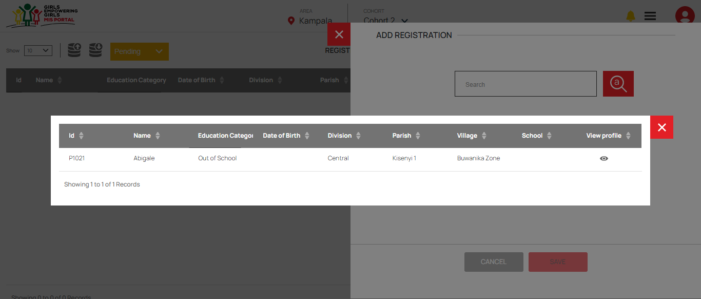A pop up will appear with the list of searched candidates, click on the **View** button to autofill the registration form with the available details of the selected candidate (see below figure).

Or, fill the following details to add selected candidate as participant -

* Enter Participant **Name**
* Upload **Participant Photograph** (Optional)
* Select Participant **DOB**
* Select **Education Category** (either In-school or Out of School)
* Enter **NIN** **Number**
* Select **Nationality**
* Select **Registration Date**
* Select **Division**
* Select **Parish** (Incase education category is selected Out of School)
* Select **Village** (Incase education category is selected Out of School)
* Select **School** (Incase education category is selected In School)
* Enter **Care taker details**
* Enter **Care taker location**

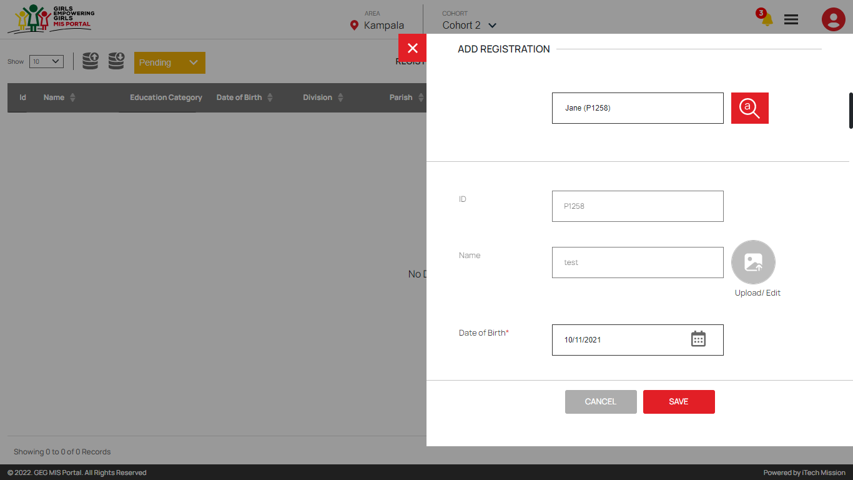All the required details are mandatory to be entered (see below figure).

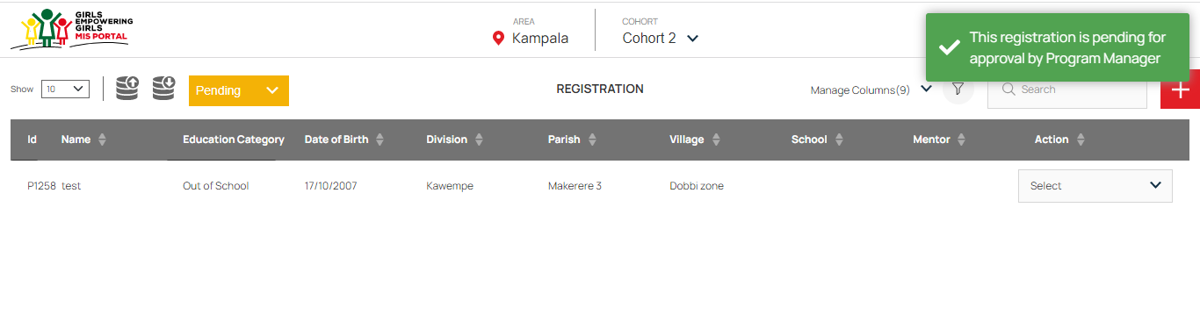Click on the **Add** button to save and confirm. You can now view the participant added in the registration list (see below figure).

The registered participant will remain in **pending** state until approved by the program manager. Click on the **Edit** option from the Action column to edit any detail of the registered participant and click on the **Update** button to save and confirm.

Click on the **Delete** option from the Action column to delete the selected participant from the registered list. When deleting a participant, a confirmation popup will appear asking to confirm deletion. If clicked Yes, the selected participant will be deleted.

Click on the **Disable** option from the Action column to disable the participant. The disabled participant will not be allowed for further cash transfer process.

### 5.3.4 Approve/Reject Registration

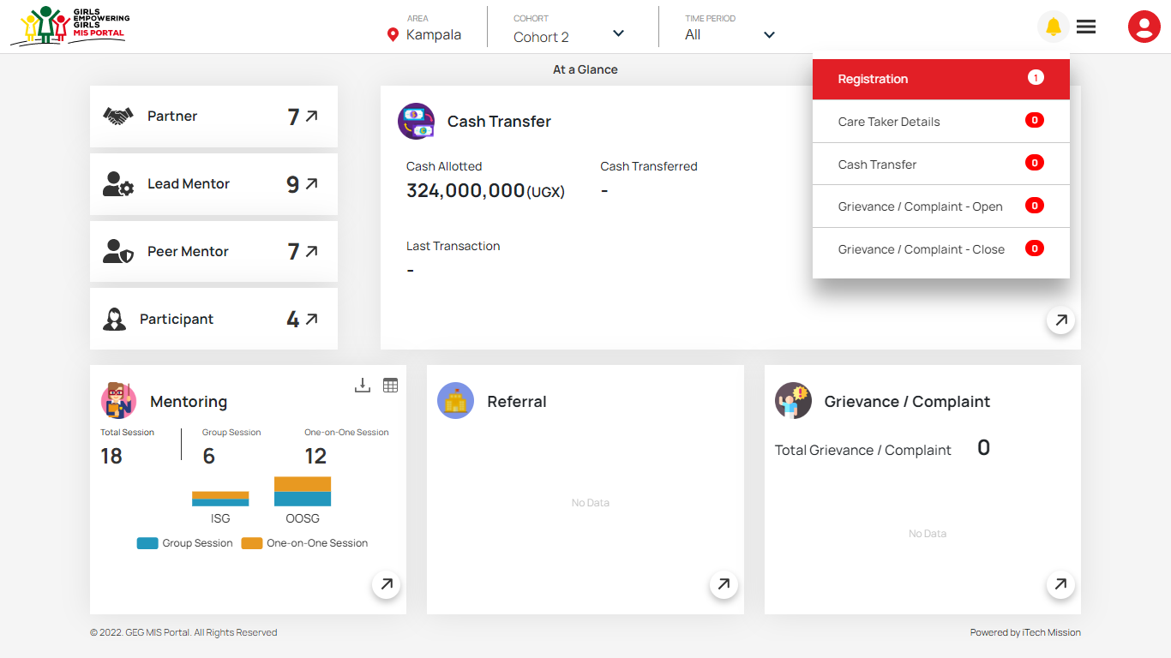You will receive notification when any participant is registered and needs approval. Click on the notification button to view the received notification (see below figure).

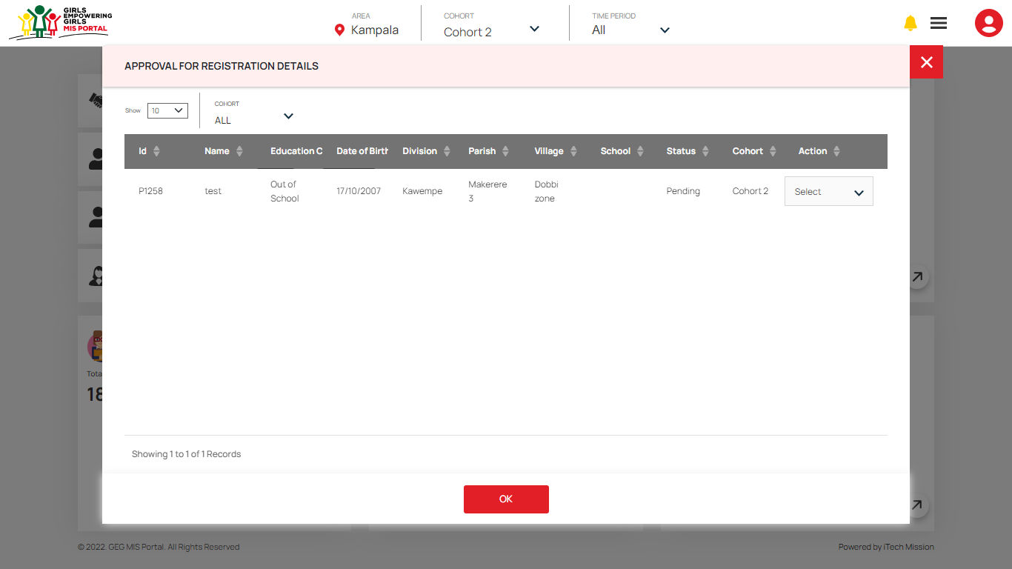Click on the **Registration** category from the notification menu to view the newly registered participants that needs approval.

Select cohort in the notification window to view all the pending participant of the selected cohort. You can approve or reject the participant from the notification window as well as using the registration module.

You have the option to Move a Pending Registration to one of the following states –

* Approved
* Rejected

#### Approve Participants

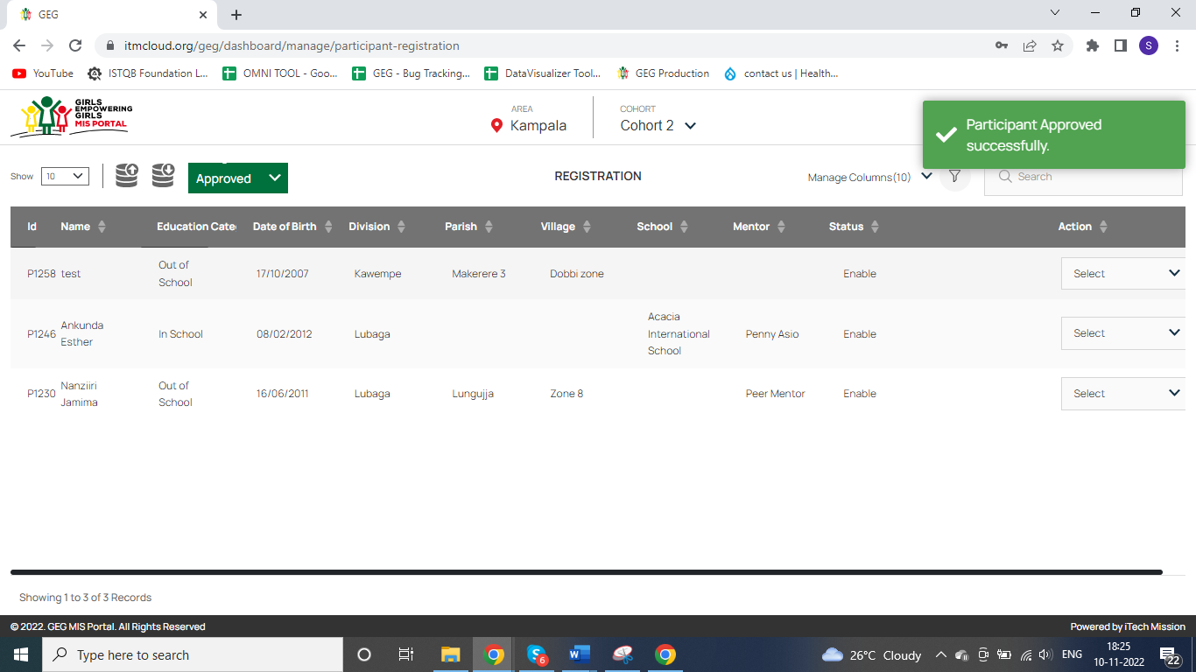In the list of Pending Registrations, click on the **Approve** option from action column to approve the selected participant. The approved participant will be moved to approved registration list and notification will be sent to the program officer for the same (see below figure).

Click on the Select dropdown to perform the following actions on the approved participants –

* View Profile
* Enable/Disable
* Edit Caretaker
* Delete
* Assign Mentor

#### Reject Participants

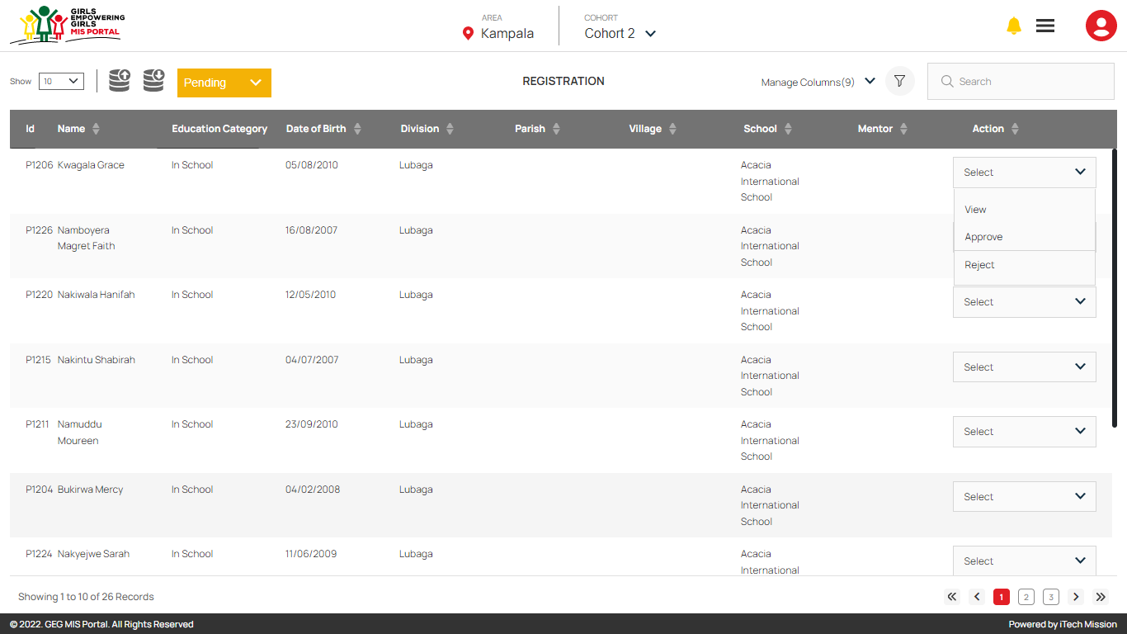In the list of Pending Registrations, click on the **Reject** option from action column to reject the selected participant (see below figure).

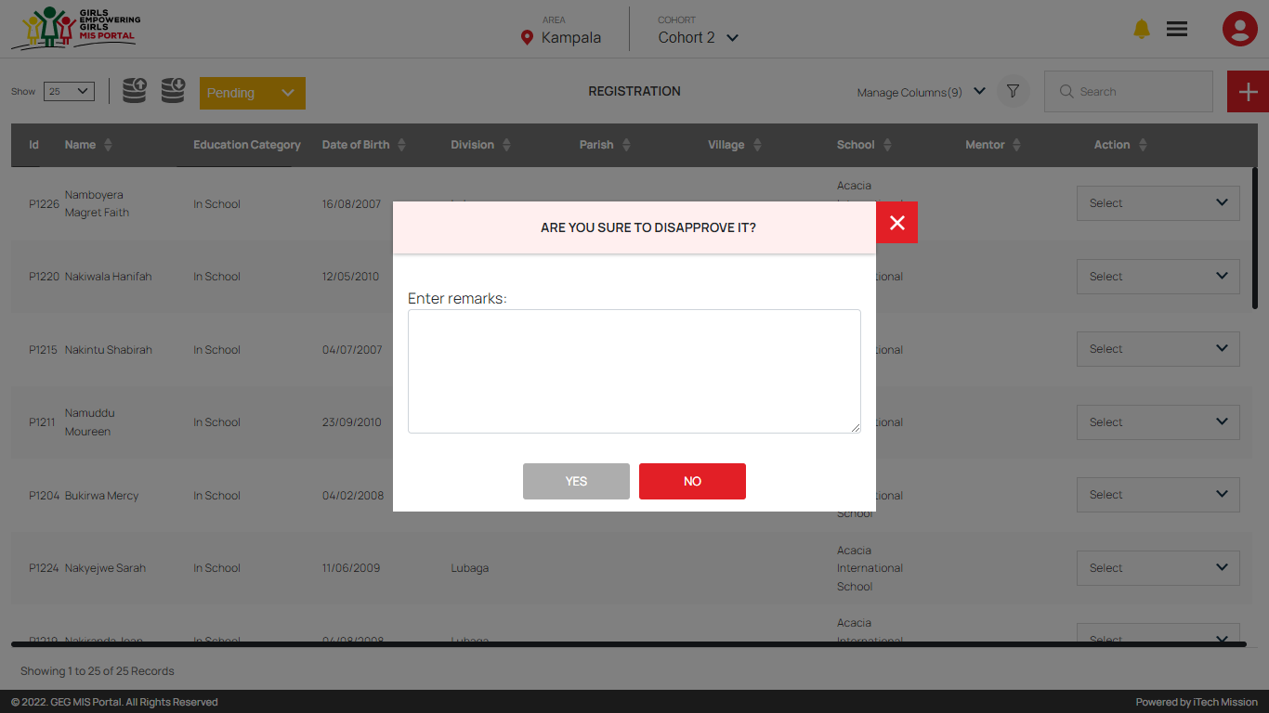You can also enter the reason of rejection when rejecting the participant (See below figure).

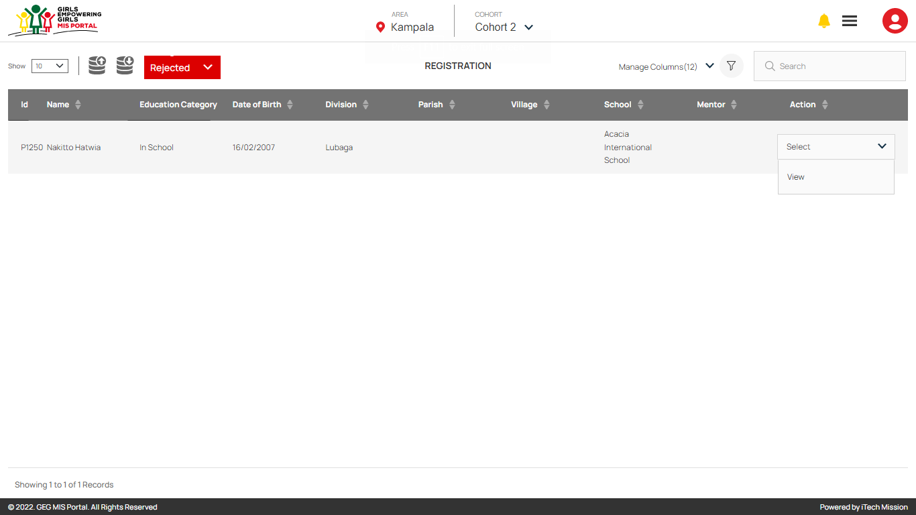The rejected participants will be moved to list of rejected participant and notification will be sent to the program officer for the same (see below figure).

You can view the detailed profile of the rejected participant by selecting **View** option from the Action column.

### 5.3.5 Assign Mentor

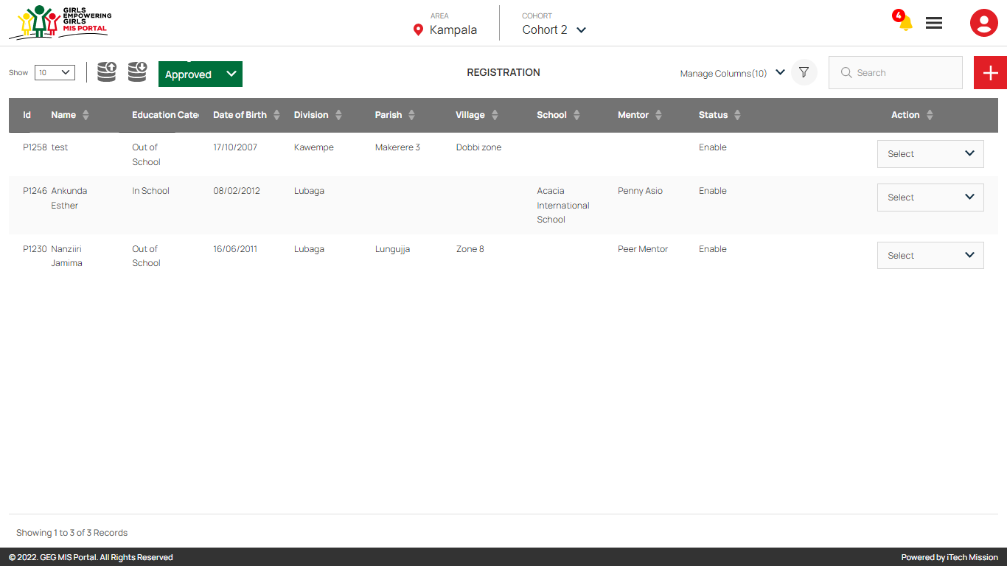Click on the dropdown available to the right side of the import button and select the option Approved to view the list of approved participants (see below figure).

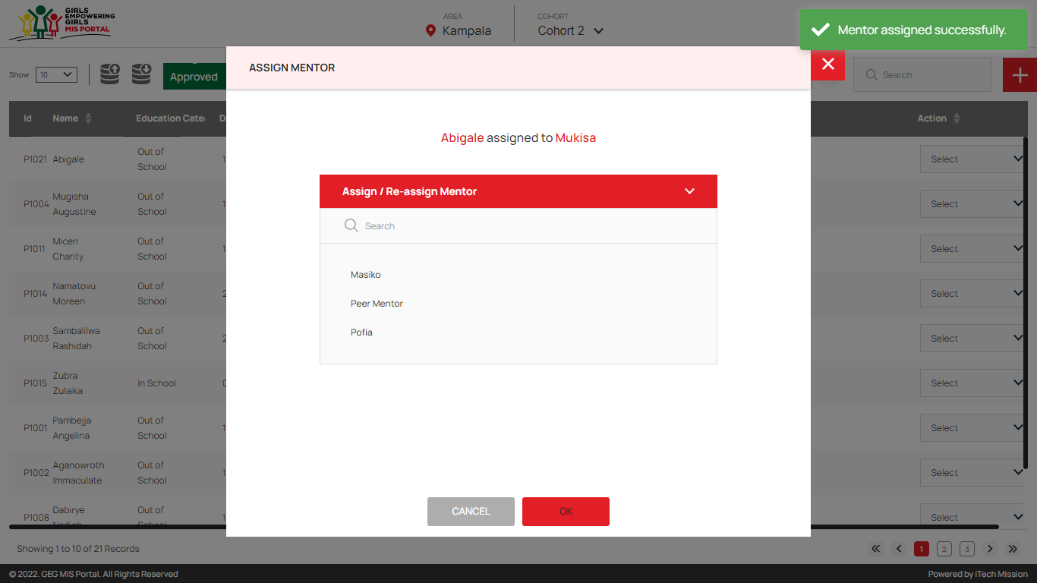Click on the Select dropdown and select the **Assign Mentor** option to assign the mentor to the selected participant (see below figure).

Once the mentor will be assigned to the participant, the following options in the select dropdown will get enabled for further process –

* Reassign Mentor
* Cash Transfer
* Mentoring
* Referral
* Grievance

## 5.4 Cash Transfer

The Cash Transfer allows to manage and track cash transfer to registered participants and its approvals. Click on the **Cash Transfer** option from **Burger** menu to access this module. This module is cohort, installment and cash transfer status driven. The cash transfer contains five steps for each installment –

1. Eligible
2. First Verification
3. Second Verification
4. Approval
5. Payment

Each cash transfer step has to go through an approval process by authorized users to move forward with the next step. Below are the actions of this module that can be performed by the authorized users -

|  |  |  |  |  |  |
| --- | --- | --- | --- | --- | --- |
| **#** | Eligible | First Verification | Second Verification | Approval | Payment |
| Admin | Checkmark | Checkmark | Checkmark | Checkmark | Checkmark |
| Program Coordinator | Checkmark | Checkmark |  |  |  |
| Lead Partner | Checkmark |  | Checkmark |  |  |
| Program Manager | Checkmark |  |  | Checkmark |  |
| Program Officer | Checkmark |  |  |  | Checkmark |

### 5.4.1 Eligible

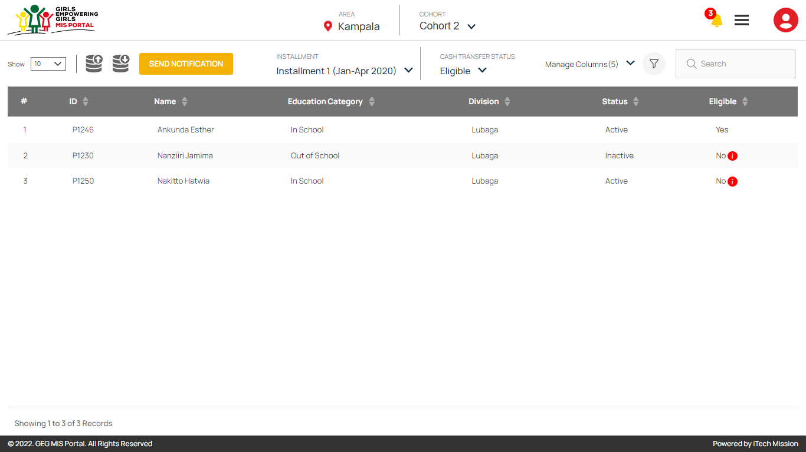The first Cash Transfer step allows you to view the participants eligibility list (see below figure). You also have the option to view the reason for non-eligibility of participants.

*“Only the participants with eligibility status Yes will be moved to next cash transfer step i.e. First Verification.”*

Hover over on the **Information** button from the Eligible column to view the reason for eligible status of the selected participant to be No.

Click on the **Export** button to download the participant eligibility in CSV file format.

Click on **Send Notification** button in order to notify the program coordinator to start the next step of Cash Transfer process.

### 5.4.2 First Verification

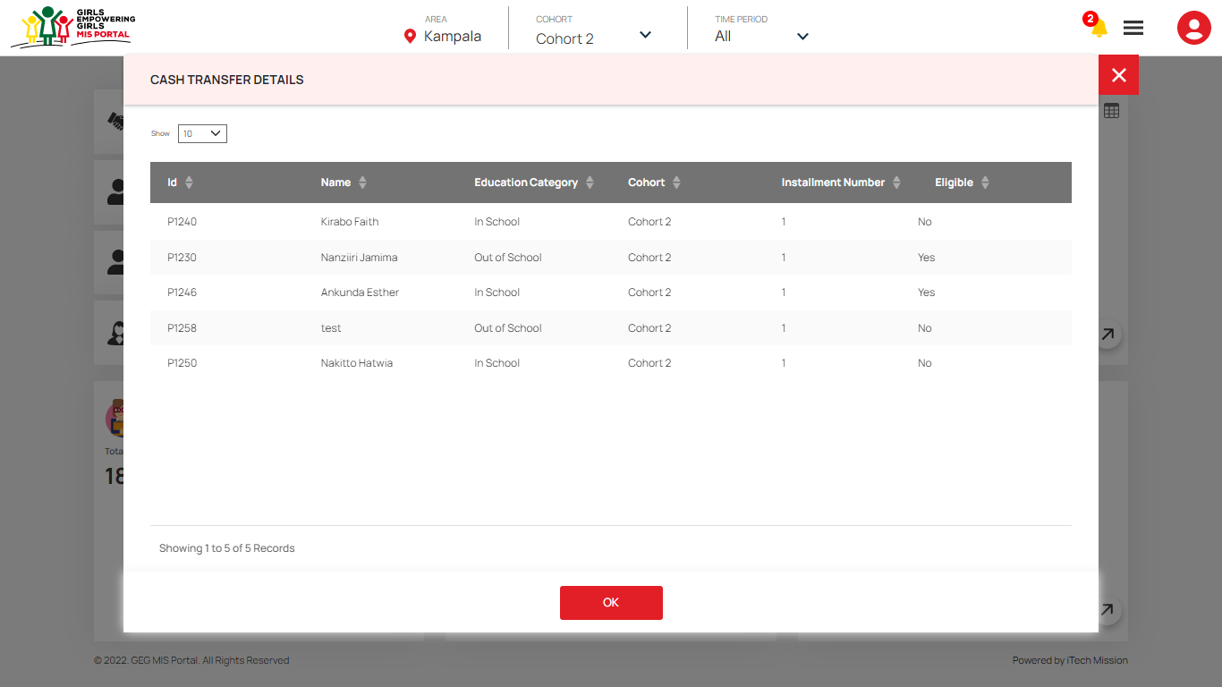In this step of cash transfer process, the eligible participants have to be verified by the Admin or the Program Coordinator to move to the next step of cash transfer process. You will receive notification to start First verification of the cash transfer process of the eligible participants. Click on the **bell** button to view the received notification in the cash transfer category (see below figure).

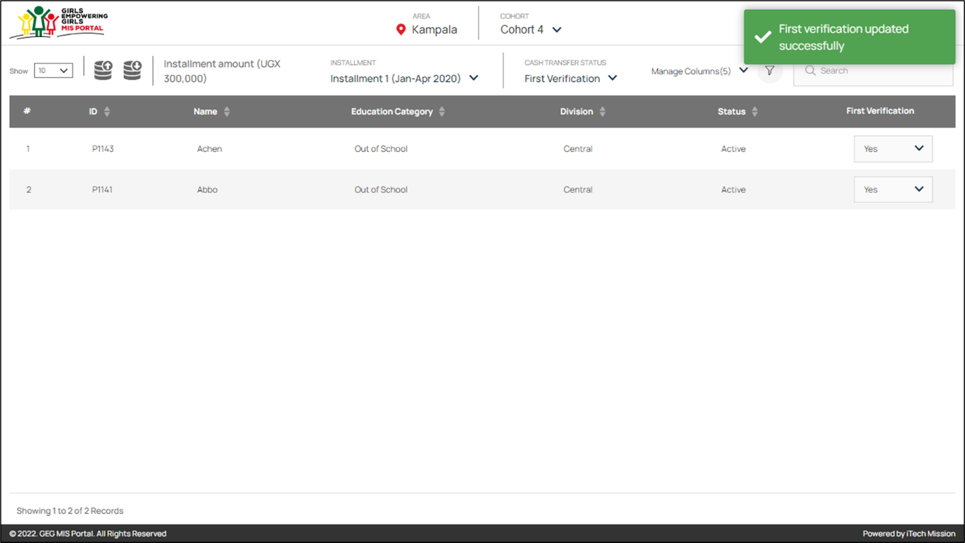Navigate to **Cash Transfer** module and select **First Verification** from the cash transfer status dropdown. Click on the **Select** dropdown available under the First Verification column. Select one of the options from Yes or No to complete the first verification of selected participant. If clicked **Yes**, theparticipant is verified and will be moved to next cash transfer process.

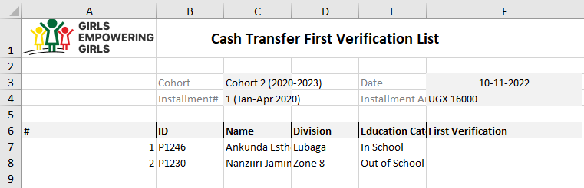Click on the **Export** button to download the first verification list in CSV format (see below figure).

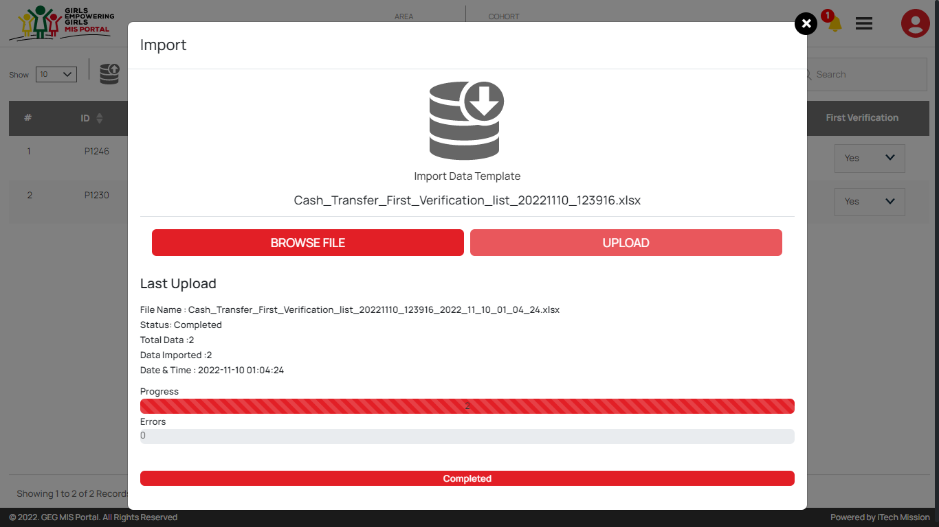To complete the first verification process of bulk participant at once, you can edit the downloaded **first verification** file and enter one of the options (Yes or No) in the First Verification column. **Save** the file in CSV format and click on the **import** option to browse the saved file and upload (see figure below).

*“Only the participants with first verification status as Yes will be moved to next cash transfer step i.e. Second Verification.”*

### 5.4.3 Second Verification

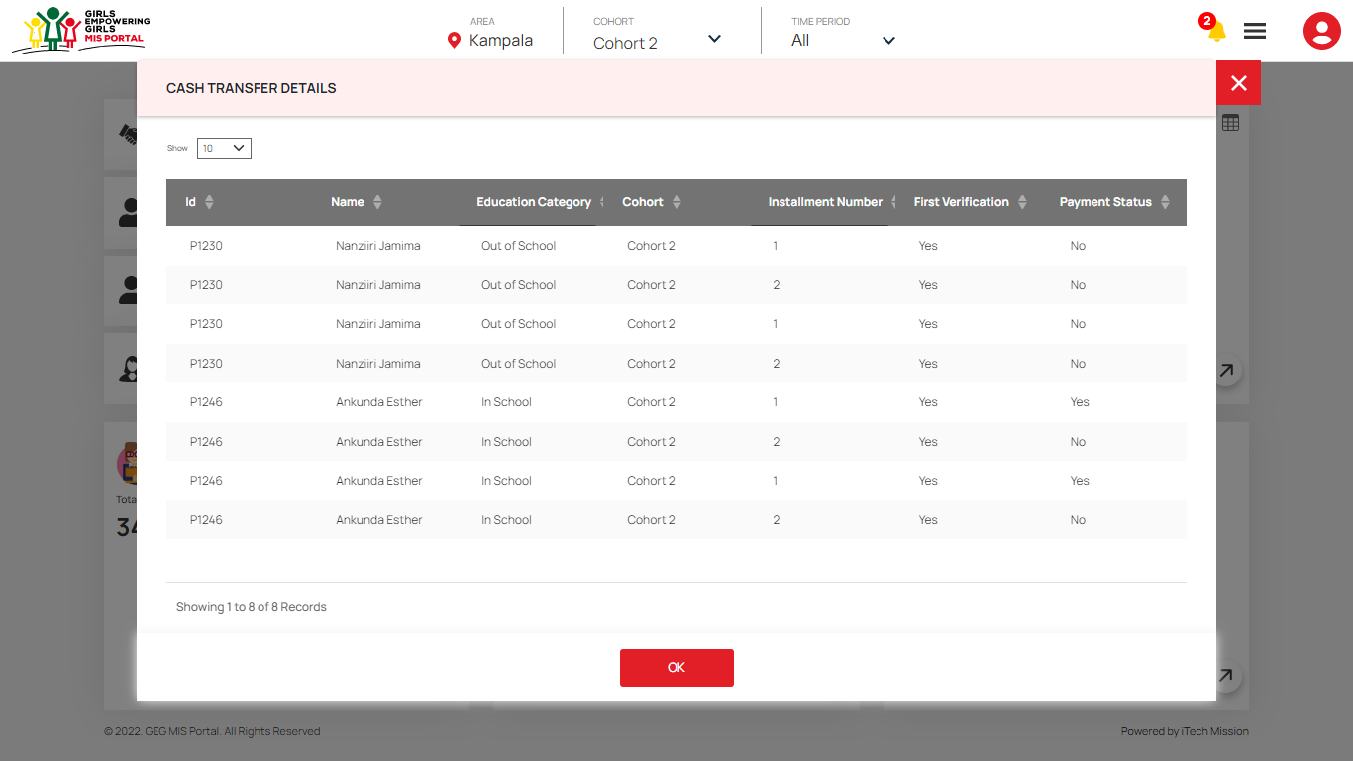In the second step of cash transfer process, the participants have to be verified by the Admin or the Lead Partner to move to the next step cash transfer process. You will receive notification when the participant will be moved to the second verification step of cash transfer process. Click on the **bell** button to view the received notification in the cash transfer category (see below figure).

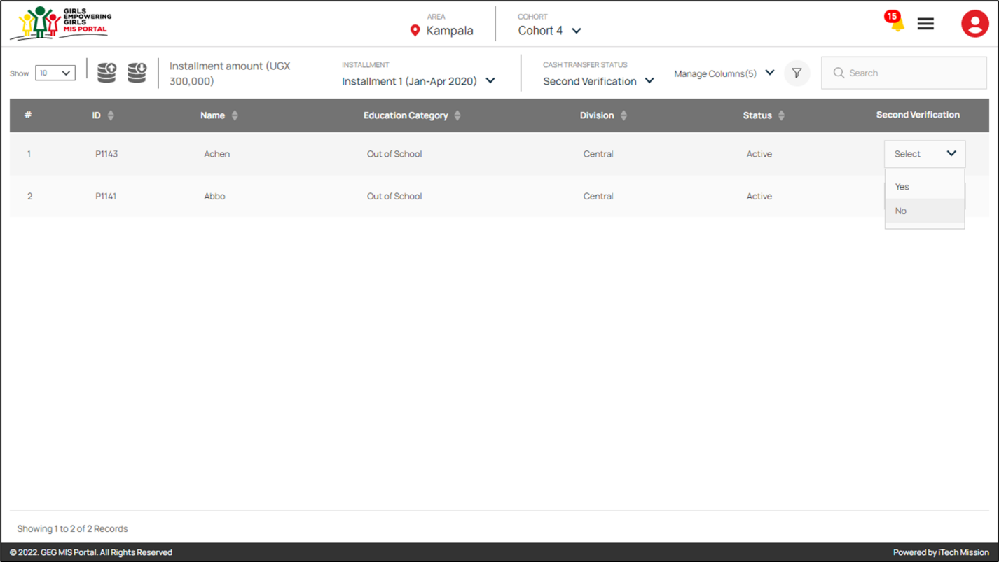Navigate to the Cash transfer module and select the **Second Verification** option from the cash transfer status dropdown. Click on the **Select** dropdown available under the Second Verification column. Select one of the options from Yes or No to complete the second verification of selected participant. If clicked **Yes**, theparticipant is verified and will be moved to next the third step of the cash transfer process i.e., Approval.

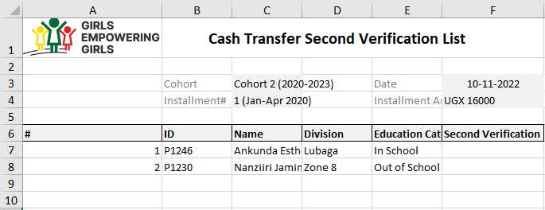Click on the **Export** button to download the second verification list in CSV file format (see below figure).

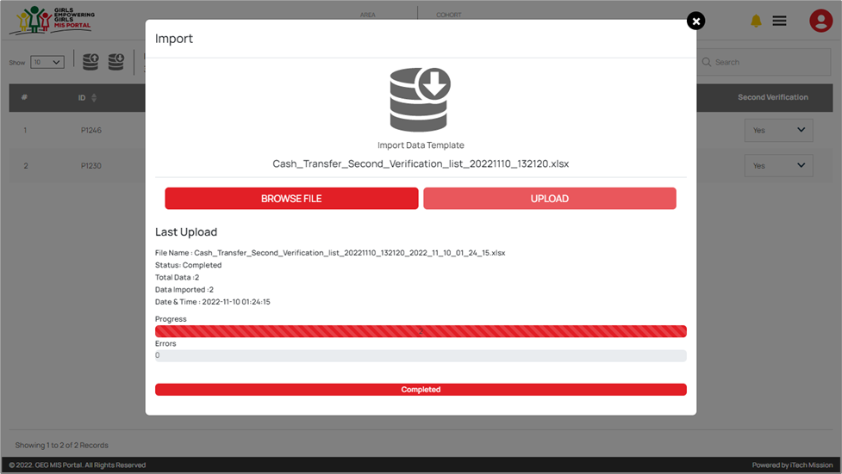To complete the second verification process of bulk participant at once, you can edit the downloaded **second verification** file and enter one of the options (Yes or No) in the Second Verification column. **Save** the file in CSV format and click on the **import** option to browse the saved file and upload (see figure below).

*“Only the participants with second verification status as Yes will be moved to next cash transfer step i.e., Approval.”*

### 5.4.4 Approval

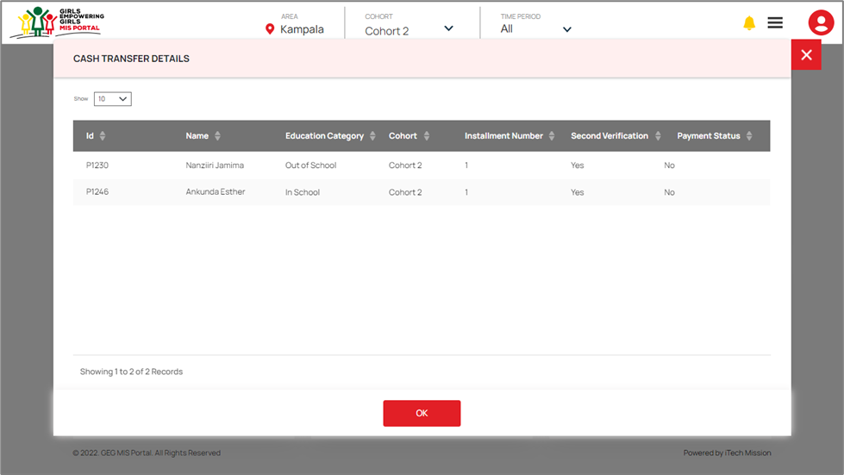In the third step of cash transfer process, Admin or the Program Manager will approve the payment of the participants whose second verification is completed. You will receive notification when the participants will be moved to the approval step of cash transfer process. Click on the **bell** button to view the received notification in the cash transfer category (see below figure).

Navigate to the Cash transfer module and select the **Approval** option from the cash transfer status dropdown. Click on the **Select** dropdown available under the Approved column. Select one of the options from Yes or No to complete the Approval of the selected participant. If clicked **Yes**, theparticipant is approved and will be moved to next the last step of the cash transfer process i.e., Payment.

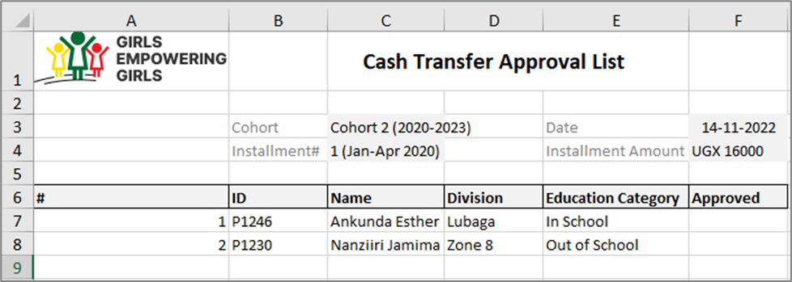Click on the **Export** button to download the approval list in CSV file format (see below figure).

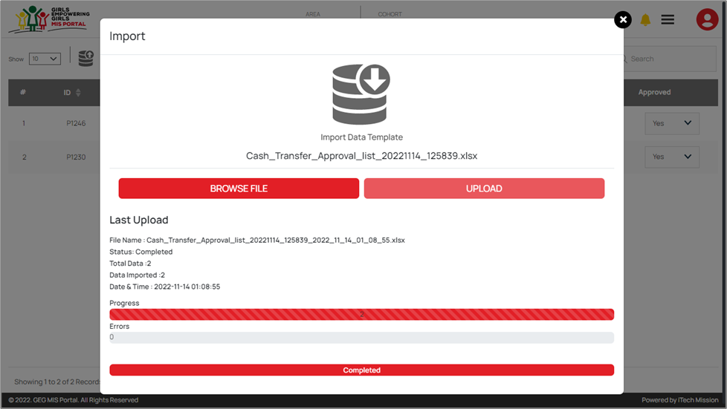To complete the approval of bulk participant at once, you can edit the downloaded **approval** file and enter one of the options (Yes or No) in the **Approved** column. **Save** the file in CSV format and click on the **import** option to browse the saved file and upload (see figure below).

*“Only the participants with approval status as Yes will be moved to next cash transfer step i.e., Payment.”*

### 5.4.5 Payment

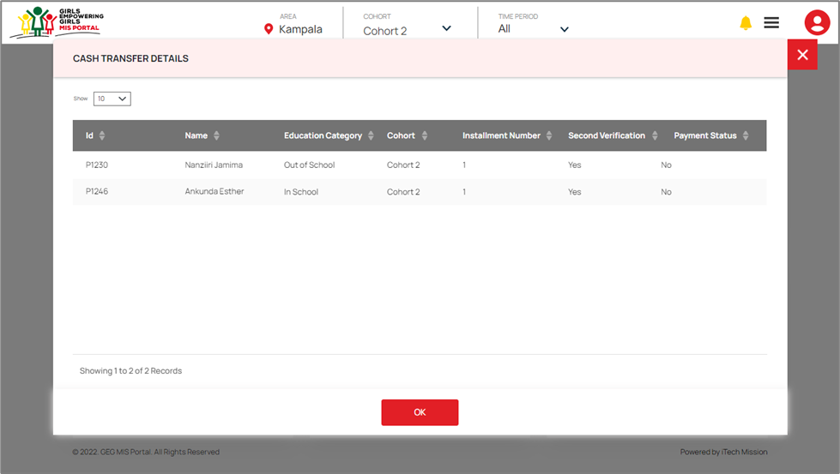In the last step of cash transfer process, the admin or the program officer will update the payment status of the approved participants. You will receive notification when the participants will be moved to the payment step of cash transfer process. Click on the **bell** button to view the received notification in the cash transfer category (see below figure).

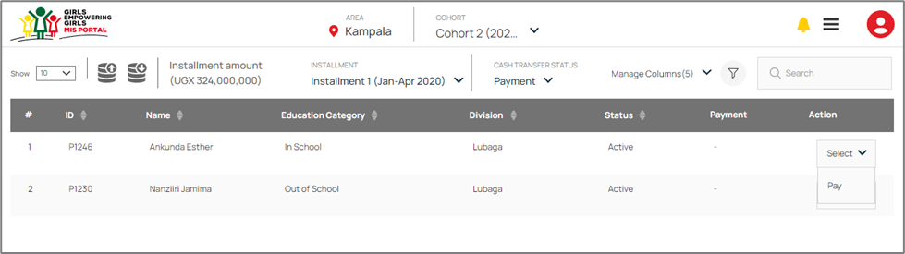Navigate to the Cash transfer module and select the **Payment** option from the cash transfer status dropdown. Click on the **Select** dropdown available under the Approved column and click on **Pay** to update the payment status (see below figure).

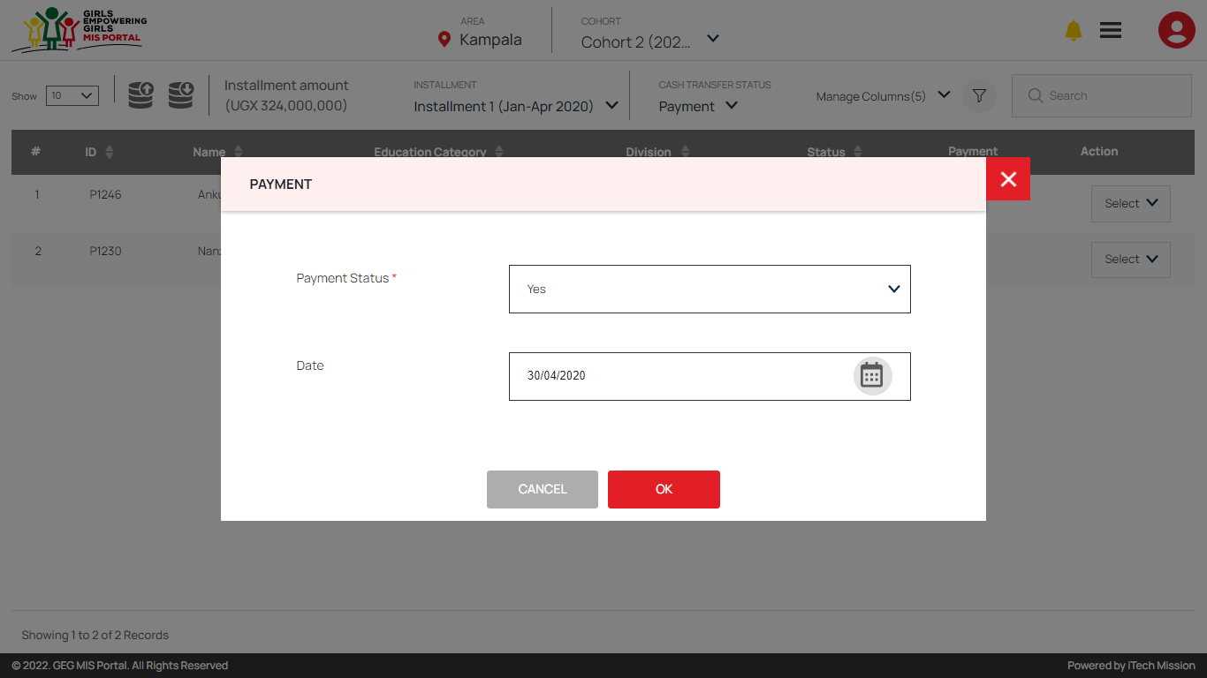A payment popup window appears, click on the payment status dropdown and select one of the options from Yes or No. If clicked **Yes**, enter the payment date and click on **Ok** to confirm (see below figure).

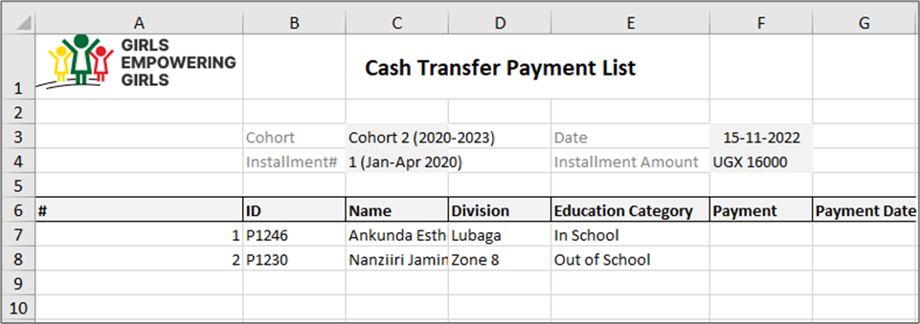Click on the **Export** button to download the payment list in CSV file format (see below figure).

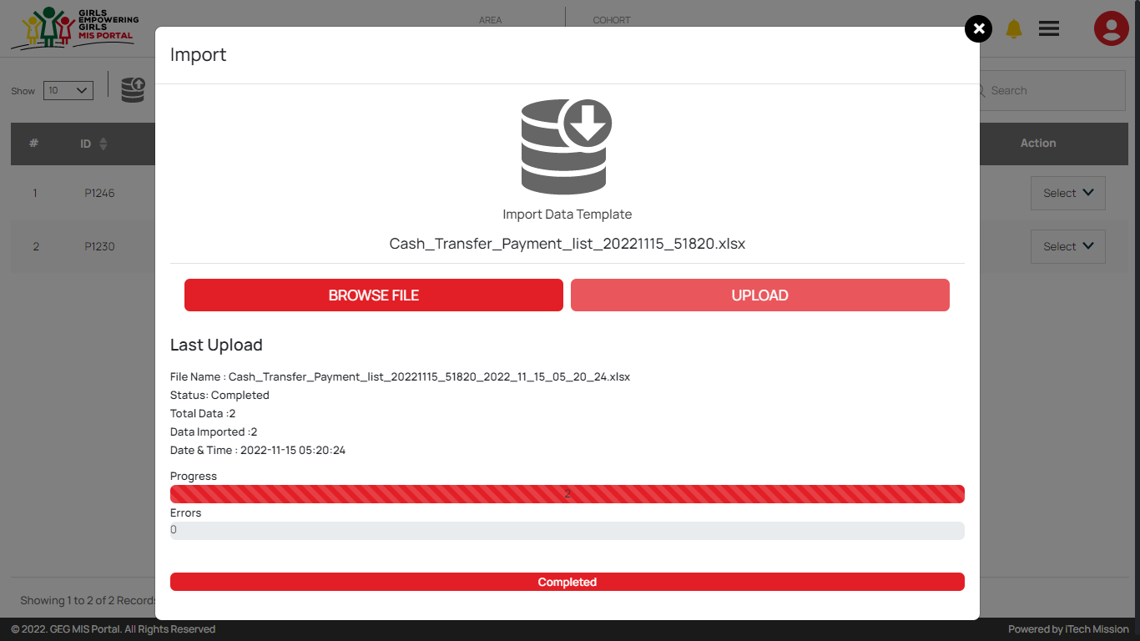To update the payment status of bulk participants at once, you can edit the downloaded **payment** file and enter one of the options (Yes or No) in the **Payment** column. In case the payment status is yes, also enter date of payment in the respective column. **Save** the file in CSV format and click on the **import** option to browse the saved file and upload (see figure below).

## 5.5 Admin

The Admin module comprises of various data management sub-modules. These sub-modules allow the creation and management of the master data. Following are the data management sub-modules -

* 1. Summary
  2. Manage Area
  3. Manage Cohort
  4. Manage School
  5. Manage Master List
  6. Manage User
  7. Manage Resource
  8. Manage Log
  9. Audit Trail

Let us understand and learn on how to use these sub-modules.

### 5.5.1 Summary

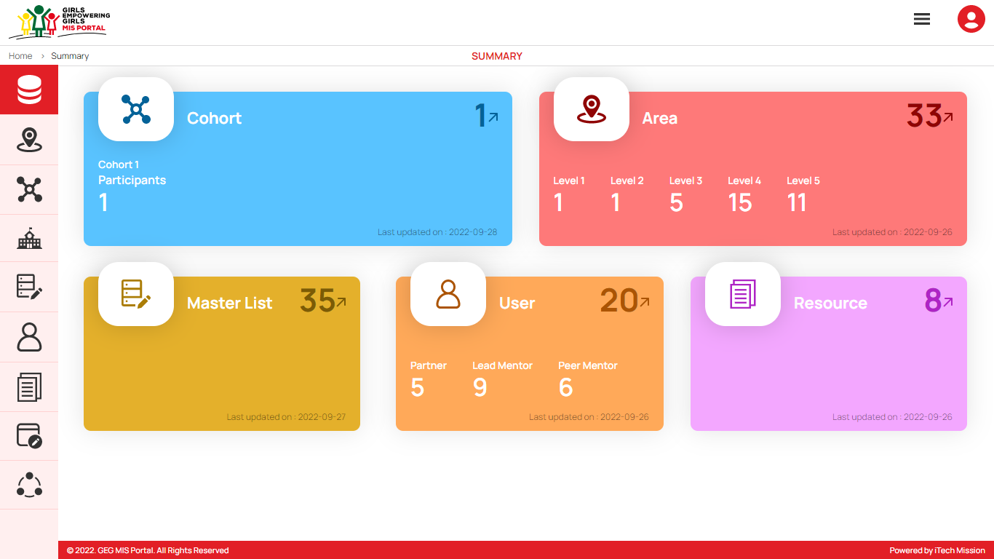The first sub-module is the **Summary.** You can also access this module by clicking on the **Summary** menu option in the left panel (see below figure).

The Data summary module depicts the following information.

1. **Cohort**

The first widget shows the total count of cohorts and the count of participants available in the database and the last date when the cohort and participant list were updated.

1. **Area**

The next widget shows the total count of geographical areas along with the count of areas which falls under area level 1 to level 5 available in the database and the last date when the area details were updated.

1. **Master List**

The first box in next row shows the total count master list available in the database and the last date when the master list was updated.

1. **Manage User**

The next box shows the total count of users along with count of users by user role partner, peer mentor and lead mentor available in the database and the last date when the user details were updated.

1. **Manage Resource**

The last box shows the total count of resources available in the database and the last date when the resources were updated.

### 5.5.2 Manage Area

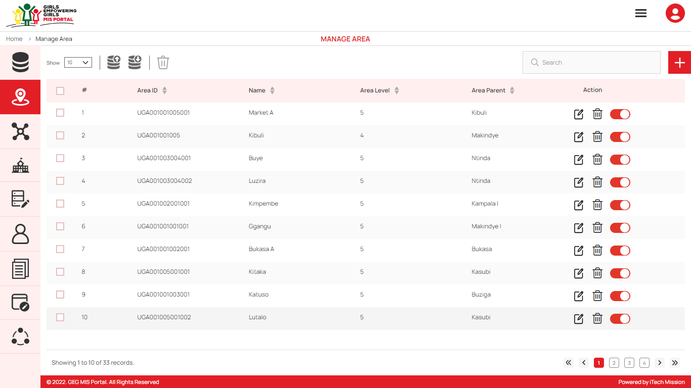To access this module, click on the **Manage** **Area** menu option in the left panel. This module allows to manage the Area master list. You will have options to export and import an area template, add new area, view the list of existing areas, sort the list, search area from the list, delete, edit update existing areas (see figure below).

#### Export Area

By clicking on the **Export** button, a pop-up window appears (see below figure). You can download the empty area template and area list available in the database.

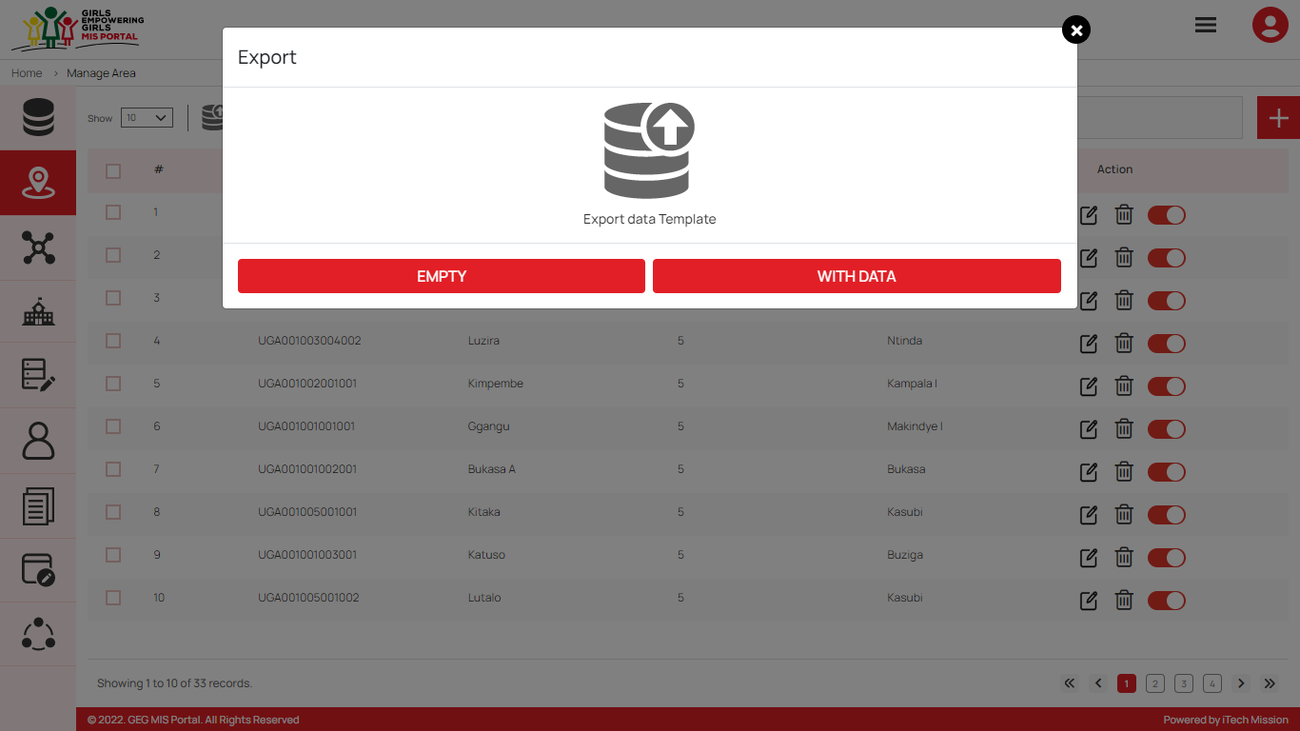You can use this option to create an area structure. Below is the area structure that you will find in the area template.

|  |  |
| --- | --- |
| **AreaID** | A unique area identification that associates the area to its map. |
| **AreaName** | Area Name assigned to an area. |
| **AreaLevel** | The level number assigned in the area hierarchy. |
| **ParentAreaID** | AreaID of the parent area. |

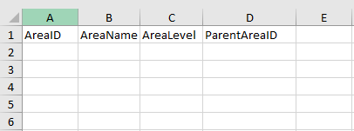By clicking on the **Empty** button, you can download an empty area template (see below figure). The area list is imported and exported in the CSV (Comma Separated Value) file format.

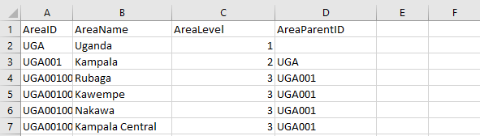Click on the **With Data** button of the download box to download the area list available in the database (see below figure).

#### Import Area

By clicking on the **Import** button, a pop-up window appears (see below figure). You have the option to browse the file and upload the area list into the database.

To upload the area into the database first enter the area structure in the template as explained above and then click on the **Browse File** button to select the template. Now, click on the **Upload** button to start the import process. During the import process, the records which contains blank entries, entries with special characters and duplicate entries are not imported in the database.

A Last Upload import summary provides the count of records which were Duplicate, Failed, successfully inserted and Updated into the database out of the total records.

Add Area

****Click on the **Plus** button available to the right side of the page to **add** a new area (see figure below). Enter the following details to add a new area.

* Select **Parent Area**
* Enter **Area ID**
* Enter Area **Name**

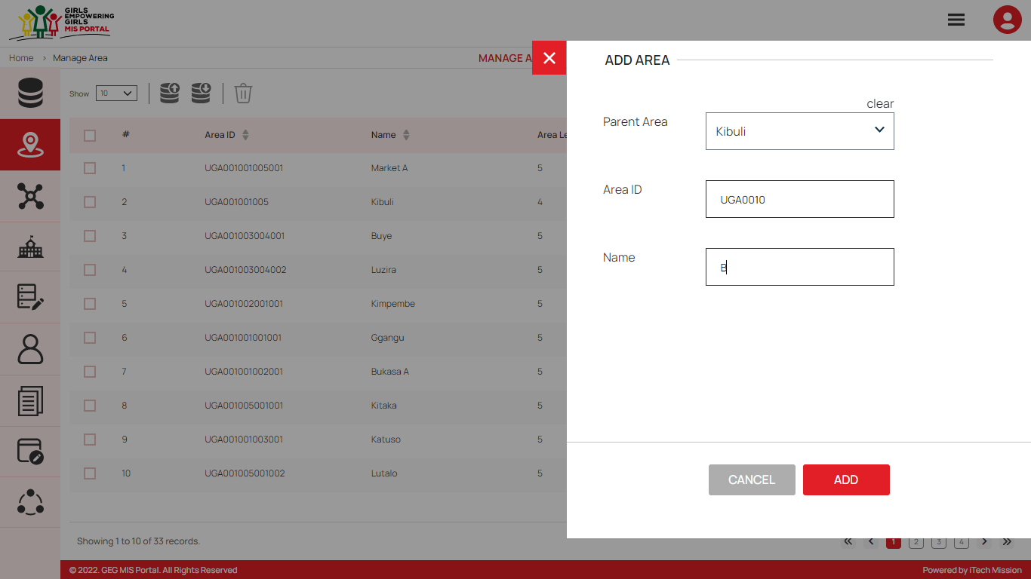All the details are mandatory to be entered. Click on the **Add** button to save and confirm. You can now view the new area added in the area list.

You can edit an area by clicking on the **Edit** button from the Action column. When you click on the edit button the edit area form will open where you can edit any detail of the area. Edit the required detail and click on the Update button to save and confirm.

You can delete an area by clicking on the **Delete** button from the Action column. When deleting a Parent area, an error message will appear stating “This area has associated child areas.”. When deleting an area, a confirmation popup will appear to confirm deletion. If clicked Yes, the selected record will be deleted.

Click on the **Status** button to enable or disable the specific area. The disabled area will not be shown in the list of area in the overall application.

### 5.5.3 Manage Cohort

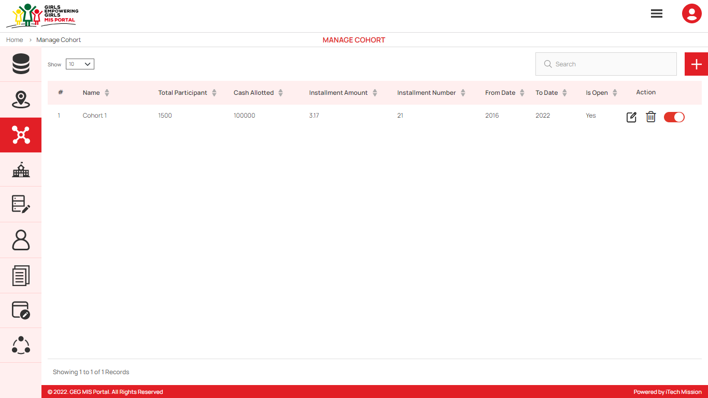To access this module, click on the **Manage** **Cohort** menu option in the left panel. This module allows to manage the Cohort master list. You will have options to add new cohort, view the list of existing cohorts, sort the list, search cohort from the list, delete, edit and enable/disable existing cohorts (see figure below).

Add Cohort

Click on the **Plus** button available to the right side of the page to **add** a new cohort (see figure below). Enter the following details to add new cohort.

* Select **Area**
* Enter cohort **Name**
* Select **Start Year**
* Select **Registration Last Date**
* Enter **Total Participant**
* Enter **Cash Allotted**
* Enter **OOSG Installment Amount**
* Enter **ISG First 2 years Installment Amount**
* Enter **ISG Last 2 years Installment Amount**
* Enter **Cohort Description**
* Select if cohort **Is Open**

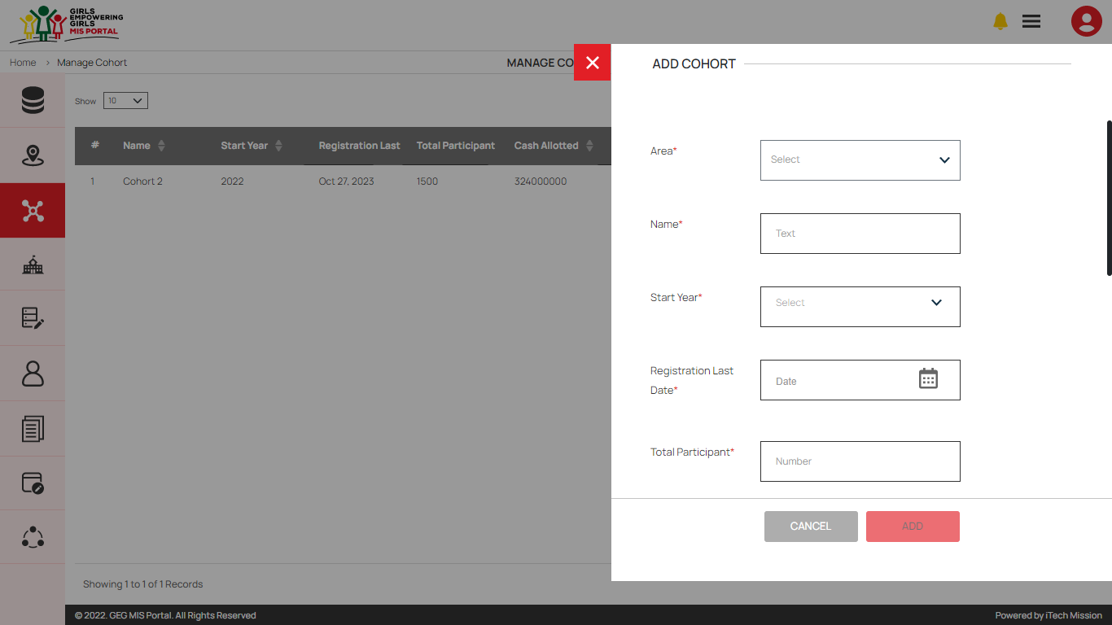All the details apart from cohort description are mandatory to be entered. Click on the **Add** button to save and confirm. You can now view the new cohort added in the cohort list.

You can edit a cohort by clicking on the **Edit** button from the Action column. When you click on the edit button the edit cohort form will open where you can edit any detail of the cohort. Edit the required detail and click on the Update button to save and confirm.

You can delete a cohort by clicking on the **Delete** button from the Action column. When deleting a cohort, a confirmation popup will appear to confirm deletion. If clicked Yes, the selected record will be deleted.

Click on the **Status** button to enable or disable the specific cohort. All the records of the disabled cohort will not be shown in the overall application.

### 5.5.4 Manage School

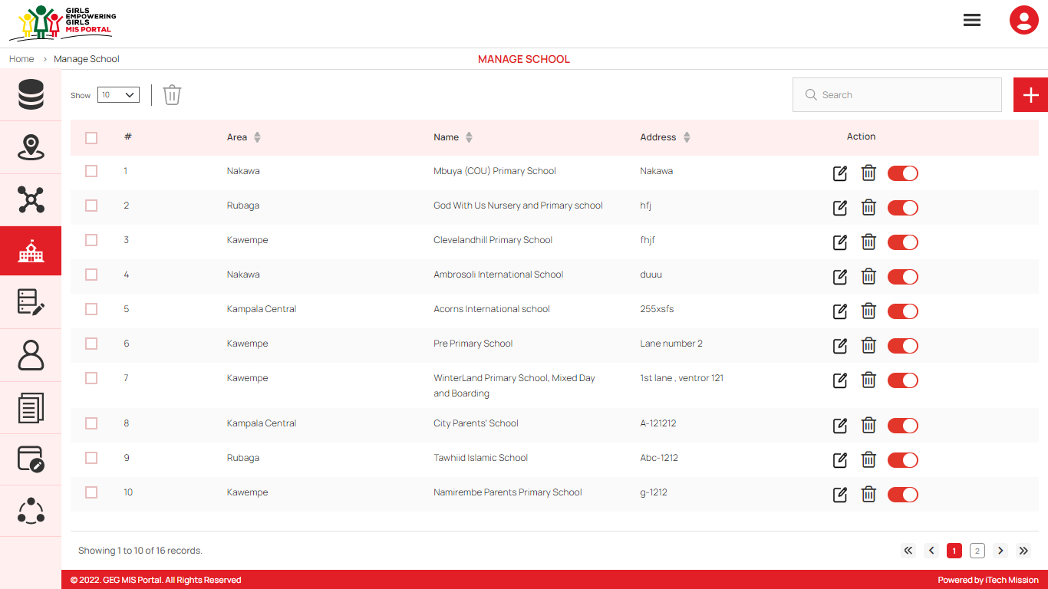To access this module, click on the **Manage** **School** menu option in the left panel. This module allows to manage the school master list. You will have options to add new school, view the list of existing schools, sort the list, search school from the list, delete, edit and enable/disable existing schools (see figure below).

Add School

****Click on the **Plus** button available to the right side of the page to **add** a new school. Enter the following details to add a new School.

* Select **Area**
* Enter **Name** of the school
* Enter **Address** of the school

All details are mandatory to be entered. Click on the **Add** button to save and confirm (see below figure).

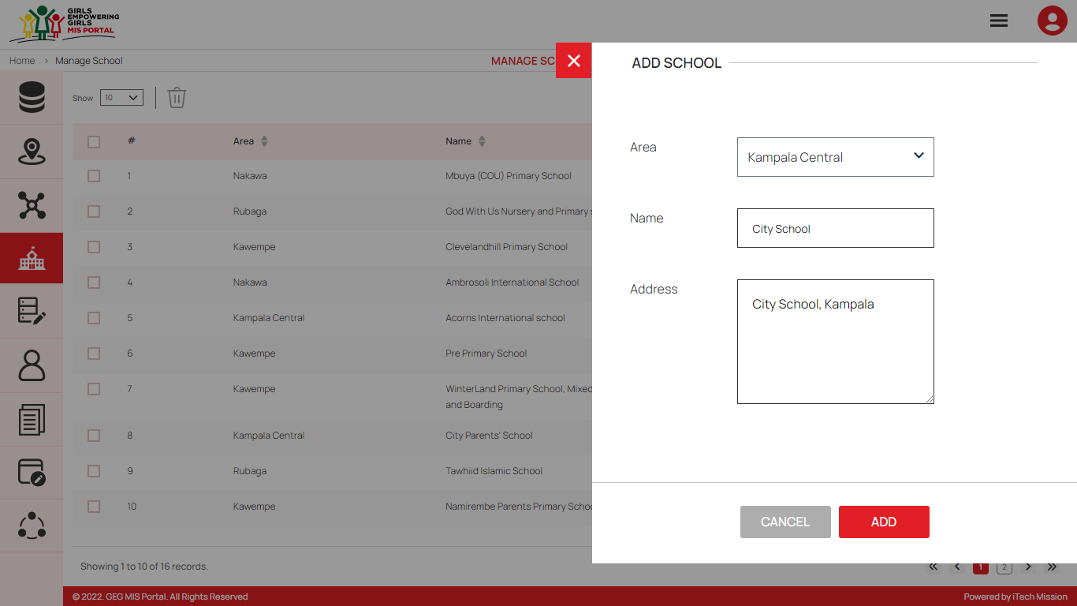You can edit a school by clicking on the **Edit** button from the Action column. When you click on the edit button the edit school form will open where you can edit any detail of the school. Edit the required detail and click on the Update button to save and confirm.

You can delete a school by clicking on the **Delete** button from the Action column. When deleting a school, a confirmation popup will appear to confirm deletion. If clicked Yes, the selected record will be deleted.

Click on the **Status** button to enable or disable the specific school. The disabled school will not be shown in the school list overall application.

### 5.5.5 Manage Master List

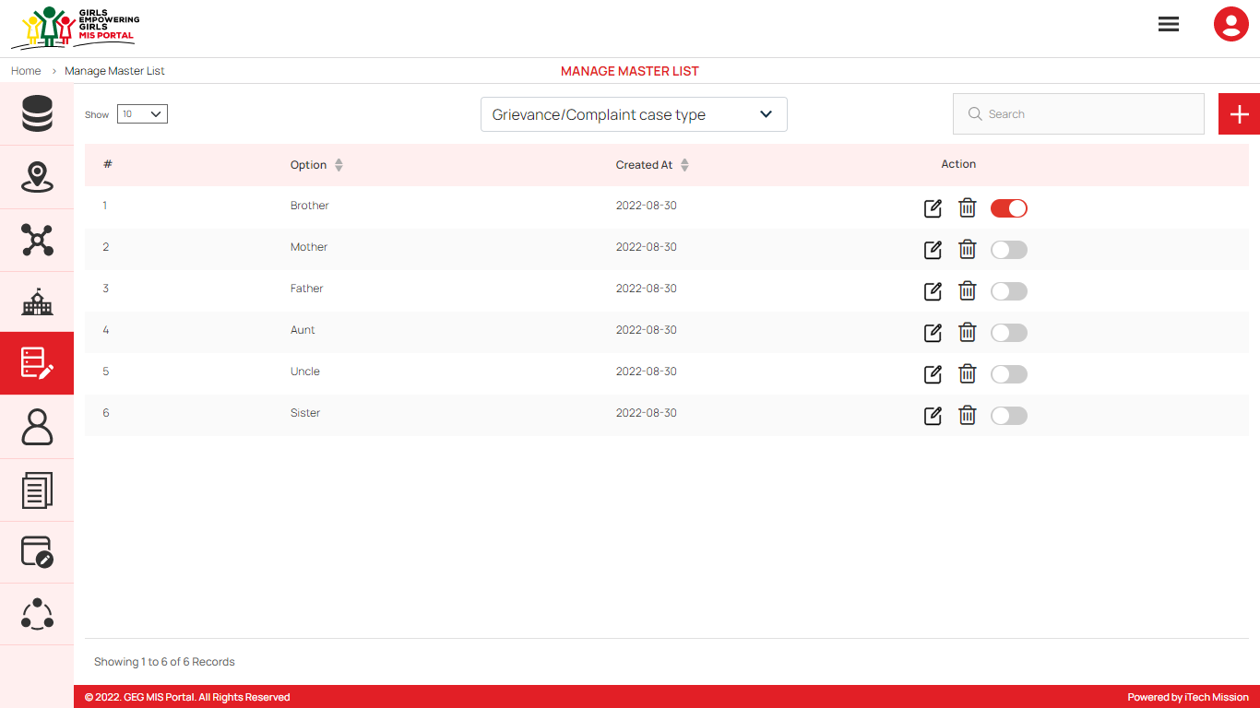To access this module, click on the **Manage** **Master List** menu option in the left panel. This module allows to manage the master list of type Grievance/Complaint case, Referral, Vulnerability, Caretaker Relationship, Caretaker Occupation, Biological Parents Alive Status, Living Status and Caretaker Responsibilities. You will have options to add new elements to all the types of master lists, view the list of existing master list filtered by type, sort each list, search elements of selected type from the list, edit and enable/disable existing elements of selected type from the list (see figure below).

Add Master List

Click on the **Plus** button available to the right side of the page to **add** a new element (see figure below). Select master type and enter option to be added in the master list of selected type. Click on the **Add** button to save and confirm add new element to the master list

You can edit an element from the master list by clicking on the **Edit** button from the Action column. When you click on the edit button the edit master list form will open where you can edit option of selected master type. Edit the required detail and click on the Update button to save and confirm.

You can delete an element by clicking on the **Delete** button from the Action column. When deleting an element, a confirmation popup will appear to confirm deletion. If clicked Yes, the selected record will be deleted.

Click on the **Status** button to enable or disable the specific element. The disabled element will not be shown in the dropdown option of selected master list overall application.

### 5.5.6 Manage User

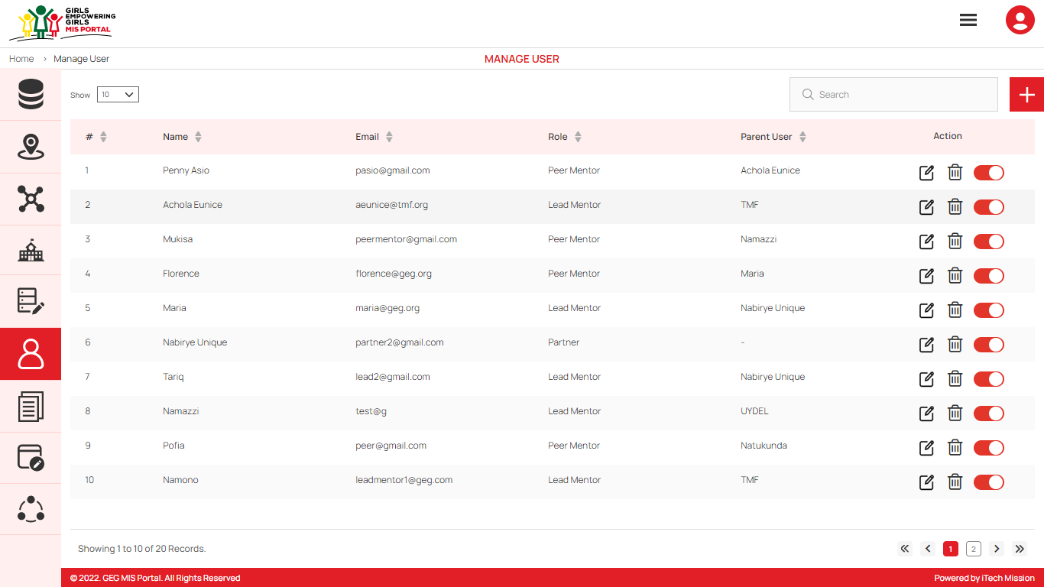To access this module, click on the **User** menu option in the left panel. This module allows to manage the User master list. You will have options to add new users, view the list of existing users, search users from the list, edit and enable/disable existing users (see figure below).

Add User

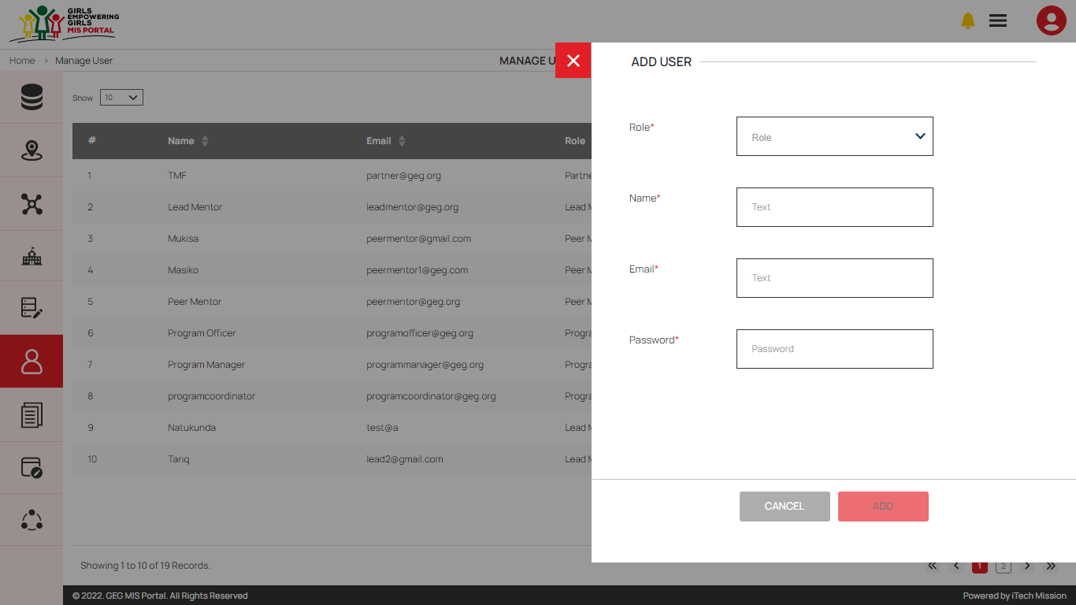****Click on the **Plus** button available to the right side of the page to add new user (see figure below).

You can create a new user and assign them one of the roles.

1. Program Manager
2. Program Co-Ordinator
3. Program Officer
4. Lead Partner
5. Partner
6. Lead Mentor
7. Peer Mentor

Enter the following details to create a new user.

* Select **Role**
* Select **Partner** (Incase the selected role is Lead Mentor)
* Select **Lead Mentor** (Incase the selected role is Peer Mentor)
* Select **Area**
* Enter **Name**
* Enter **Email ID**
* Enter **Password**

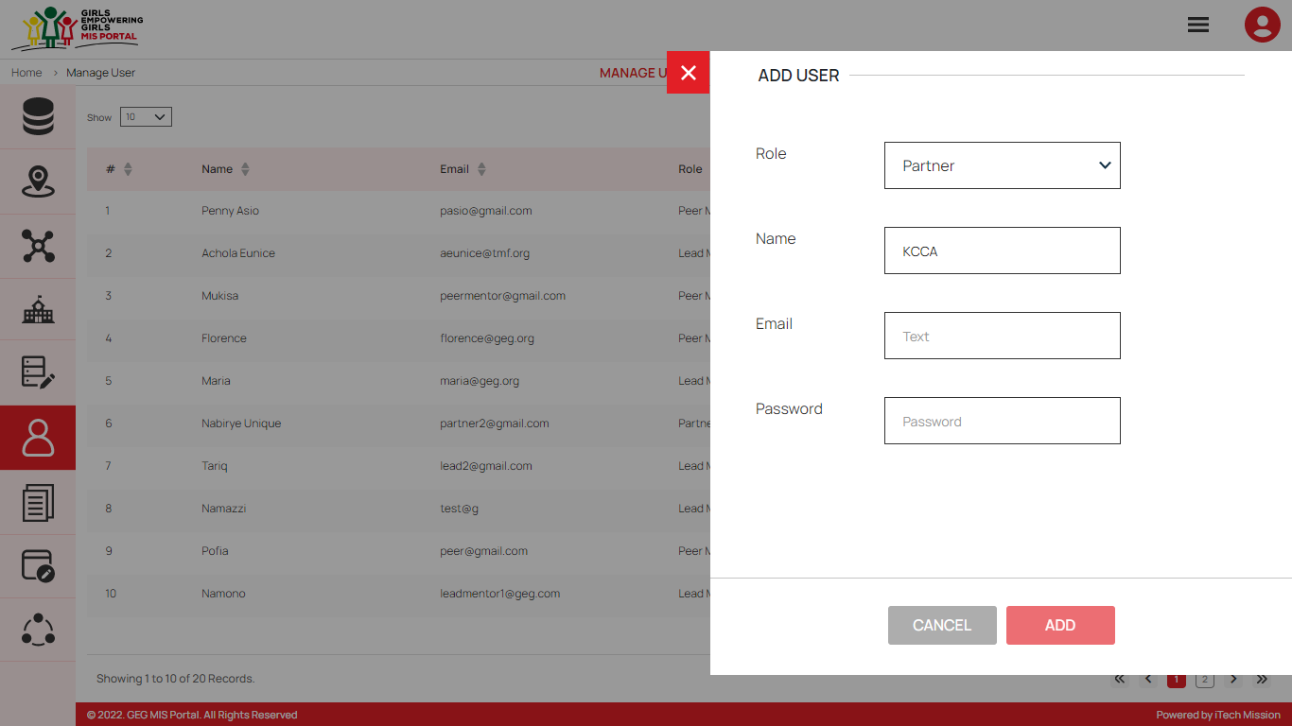Click on the **Add** button to save and confirm. You can now view the new user added to the list.

You can edit a user by clicking on the **Edit** button from the Action column. When you click on the edit button the edit user form will open where you can edit any detail of the user. Edit the required detail and click on the Update button to save and confirm.

You can delete a user by clicking on the **Delete** button from the Action column. When deleting a user, a confirmation popup will appear to confirm deletion. If clicked Yes, the selected record will be deleted.

Click on the **Status** button to enable or disable the specific school. The disabled user will not be shown in the user list overall application.

### 5.5.7 Manage Resources

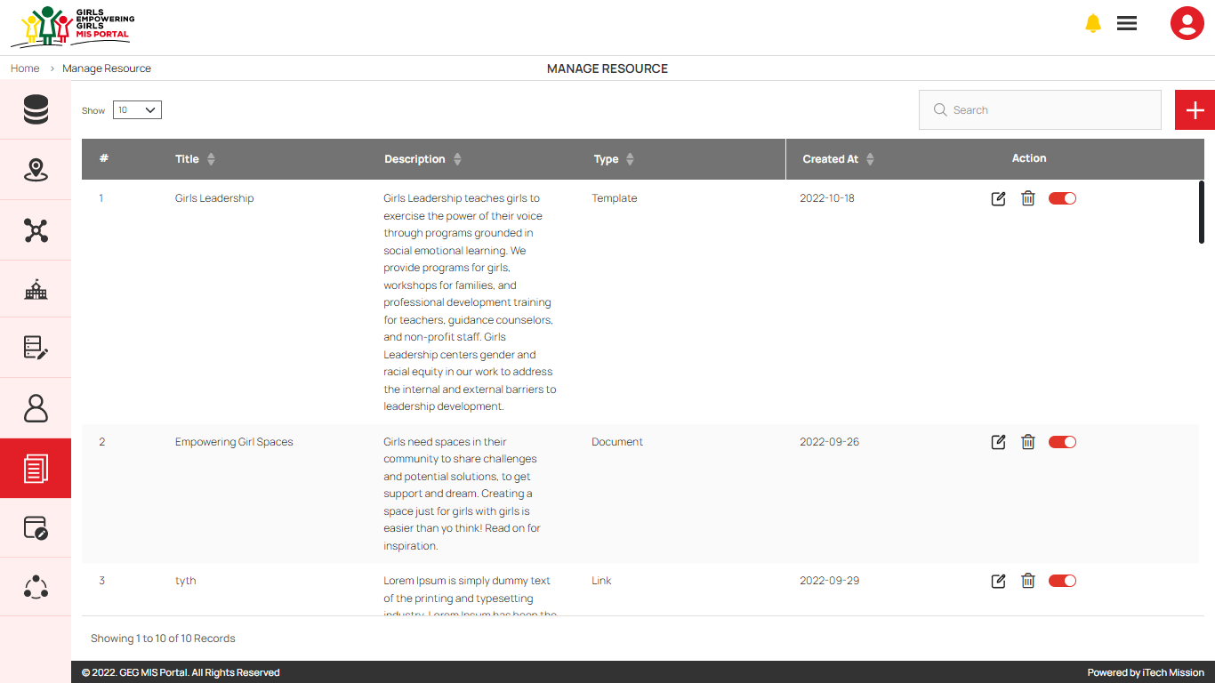To access this module, click on the **Resource** menu option in the left panel. This module allows to manage the Resource master list. You will have options to add new resource, view the list of existing resources, search resource from the list, edit existing resource from the list (see figure below).

Add Resource

****Click on the **Plus** button that is available to the right side of the page to Add a new resource (see figure below). Enter the following details to create a new resource.

* Enter Resource **Title**
* Enter **Description**
* Select Resource **Type**
* Upload document (Incase the resource type is document and template)
* Enter URL (Incase the resource type is URL)
* Upload Resource Image

Click on the **Add** button to save and confirm. You can now view the new resource added to the list.

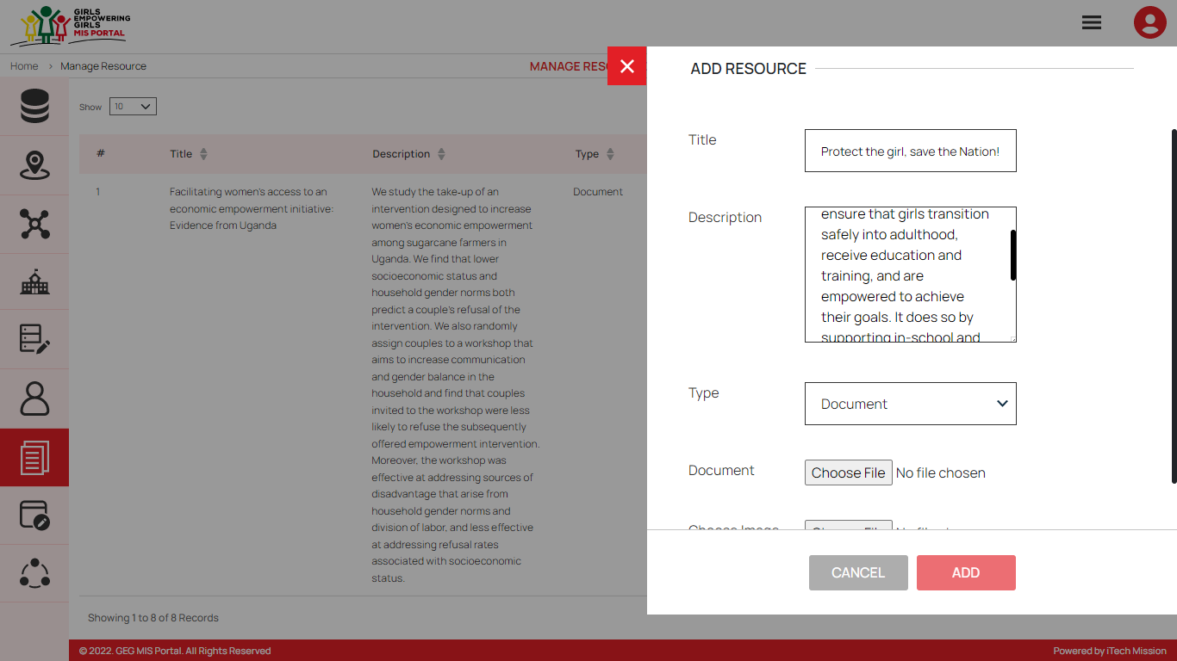You can edit a resource by clicking on the **Edit** button from the Action column. When you click on the edit button the edit resource form will open where you can edit any detail of the resource. Edit the required detail and click on the Update button to save and confirm.

You can delete a resource by clicking on the **Delete** button from the Action column. When deleting a resource, a confirmation popup will appear to confirm deletion. If clicked Yes, the selected record will be deleted.

Click on the **Status** button to enable or disable the specific resource. The disabled resource will not be shown in the Information Kiosk module of User Interface application.

### 5.5.8 Manage Log

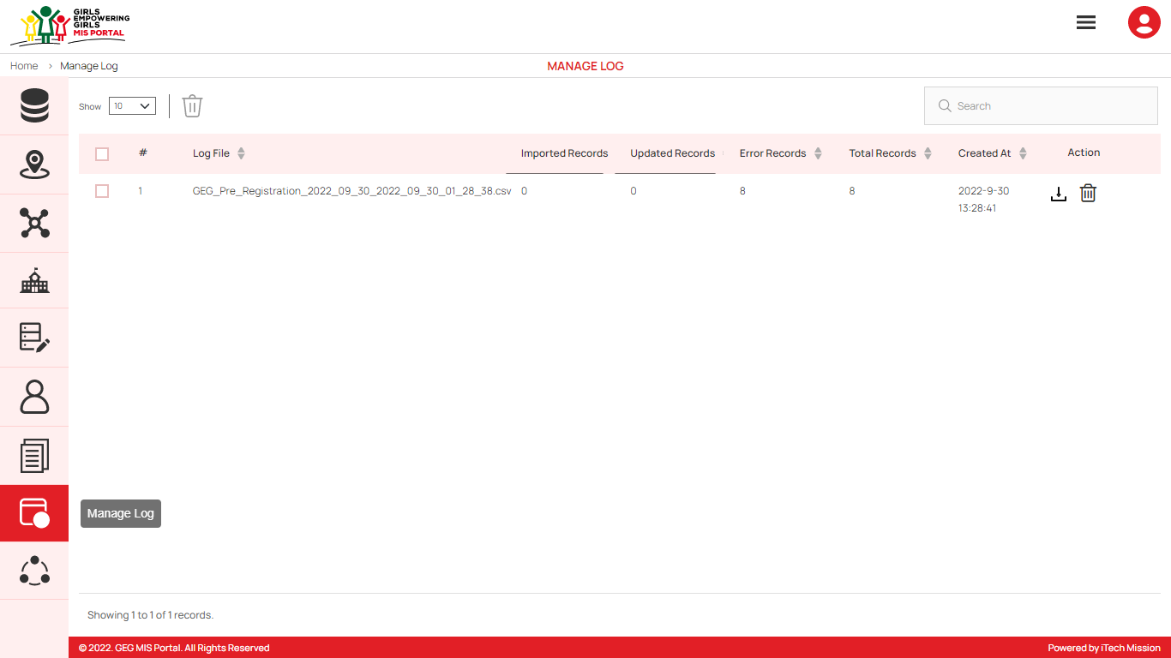To access this module, click on the **Manage** **Log** menu option in the left panel. This module allows to manage the Data Import Log master list. You will have options to view the list of existing logs, download and view log reports and delete selected records (see figure below).

A log will be generated whenever any data template will be imported into the database. A list of import logs is shown on this page where each import log is shown as a row. You can see the file name of each import log along with the log summary that includes: count of records imported, count of records updated, count of error records, total records available in the import file and date & time of the import. You also have the options to download the log file in order to view the reason of error records, or delete the log file. The log file will be downloaded in CSV format.

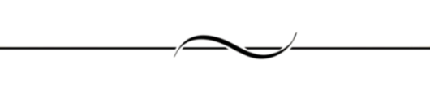END OF THE DOCUMENT